Cheet Sheets: Windows 2000 Server (70-215)
Copyright Keen Interactive 2000

Last updated 8/18/00

- You have been instructed to implement auditing for the domain of which you are the administrator. The domain is on a network that uses a Windows 2000 Server computer and Windows 2000 Professional client computers.

After determining the best way to implement auditing for the domain, you determine you need to create an audit policy.

How will you implement the audit policy?
- Create a separate audit policy for each domain controller in the domain
- Create a separate group policy for each domain controller in the domain
- Create a group policy that will apply to all domain controllers in the domain
- Create an audit policy that will apply to all domain controllers in the domain

- You use Setup Manager to create an answer file for an unattended installation of Windows 2000 Server. Which components can you specify using Setup Manager? (Choose all that apply.)
- Create Txtsetup.oem files
- Configure network settings
- Create a subfolder in the distribution folder
- Configure the installation to install IIS
- Define user name options such as creating a Uniqueness Database File to access a file of valid computer names

- You must properly configure Internet Information Service (IIS) ports on your Windows 2000 server to meet the following requirements:

You must configure the proper port so you can control a router via Telnet.
You must configure the proper port so all clients can connect to a secure HTTP server.
You must prevent users from accessing newsgroups.
You must configure the proper port for HTTP service to all clients.

You take the following actions:
You open port 80 on the IIS server.
You block port 119 on the IIS server.
You open port 23 on the IIS server.
You open port 443 on the IIS server.

Which requirements do the actions meet? (Choose all that apply.)
- The IIS service is configured properly so all clients can use HTTP
- The IIS service is configured so the router can be configured via Telnet
- The IIS service is configured so all clients can connect to a secure HTTP server
- The IIS service is configured properly so all clients are prevented from accessing newsgroups

- You have a Pentium III 400 MHz Windows 2000 Server computer with a built-in sound card on the motherboard. You must install a high-end sound card that is on the HCL and enable it on the server. How should you configure the computer to use the new sound card and install the drivers for the sound card? (Choose three.)
- Disable the sound card in the CMOS
- Install the new sound card into the computer
- Disable the integrated sound card in Device Manager
- Use the Add/Remove Hardware Wizard and manually install the sound card
- Install the driver from the Driver tab of the existing sound card’s Properties page in the Device Manager
- Let Windows 2000 automatically detect the new sound card during the next boot of the computer after the sound card is installed

- You are the head of the MIS department of your company. You are required to travel about 25% of the time to various remote locations. The corporate office network consists of 17 Windows 2000 domain controllers that use the Cluster Service. One of the domain controllers has Terminal Services and Routing and Remote Access installed on it. When you travel, you must be able to edit the registry of the Windows 2000 server at the corporate office while using a remote access connection from a laptop computer. How can you configure this functionality?
- Use WINS to edit the registry
- Use Terminal services to edit the registry
- Use Routing and Remote Access to edit the registry
- Use Routing and Remote Access to connect to the Terminal Server and edit the registry

- Your Windows 2000 server runs three 16-bit applications. The applications have their default installation settings and were installed in Windows NT 4.0. The Windows NT 4.0 server was then migrated to Windows 2000. You want to monitor the performance of these applications using the Process Performance object of Performance Monitor. How can you monitor these applications?
- Monitor the %Processor Time counter
- Monitor the %Privileged Time counter
- Monitor the NTVDM for each application
- Monitor a single Windows Virtual DOS machine

- You have a hard disk fail in your Windows 2000 server. The disk was part of a RAID level 1 configuration. You replace the hard disk with an identical disk. How can you restore the RAID 1 volume?
- Reactivate the disk
- Recreate the volume
- No action is necessary
- Scan the volume for changes

- A Windows 2000 domain controller has two Pentium III processors in it and you are required to assign the Exchange.exe process to one of the processors exclusively. How can you perform this function?
- This configuration is not possible
- Right-click the Exchange process, select Set priority, and select Low
- Right-click the Exchange process, select Set priority, and select High
- Right-click the Exchange process, select Set priority, and select Realtime
- Right-click the Exchange process, select Set Affinity, and select the approptiate processor

- Your company is adding 75 Windows 2000 servers to your network. The servers are Pentium II 400 MHz with 514 MB of RAM and five 30-GB SCSI hard drives. They have 100-Mbps Ethernet cards and writable CD-ROM drives. You are in charge of deploying Windows 2000 Server on these computers. After formatting a partition and establishing network connectivity, you must install the software via an unattended installation. You must specify a Uniqueness Database File (UDF) and an answer file. How can you configure the answer file? (Choose all that apply.)
- Use Notepad to create the answer file unattend.txt
- Use notepad to create the answer file unattend.msi
- Use Setup Manager to create the answer file unattend.msi
- Use Setup Manager to create the answer file unattend.txt

- You must implement a 140-node network. You must divide the network into 10 subnets and each subnet must be able to accommodate up to 14 nodes. How should you configure the IP addressing structure to allow for this configuration if the company's IP address is 194.194.194.0?
- 194.194.194.0/25
- 194.194.194.0/26
- 194.194.194.0/27
- 194.194.194.0/28

- You administer a Windows 2000 network that uses the Encrypting File System (EFS) to encrypt data. You are installing a new server that has a 6-GB NTFS partition.

You want to move several EFS folders to a new server and preserve encryption throughout the migration.

What is the best way to accomplish this task?
- Compress the folder by enabling file compression
- Decrypt, move, and re-encrypt the folder using EFS
- Back up the folder using the Backup utility in Windows 2000
- Decrypt the folder and compress the folder by enabling file compression
- Decrypt the folder and back up the folder using the Backup utility in Windows 2000

- Your Windows 2000 network consists of 10 Windows 2000 Professional computers and a Windows 2000 domain controller running Windows 2000 Server. All the users of the Windows 2000 Professional computers are attorneys, paralegals, or administrative assistants, and they must print to various types of forms. Your network has a single Hewlett Packard 5SI printer on it. You must configure the printer as follows:

All legal-sized documents print to the printer’s upper tray.
All letter-sized documents print to the lower tray.
The print mode is specified as PCL and a separation page is configured to print before printing each document.
All members of the Attorneys group have the minimum permissions required to print to the printer.

You take the following actions:
You set up the HP LaserJet 5SI Properties for Device Settings as shown here:
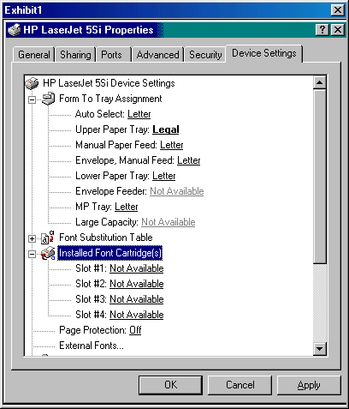
You set up the HP LaserJet 5SI Properties for printing as shown here:
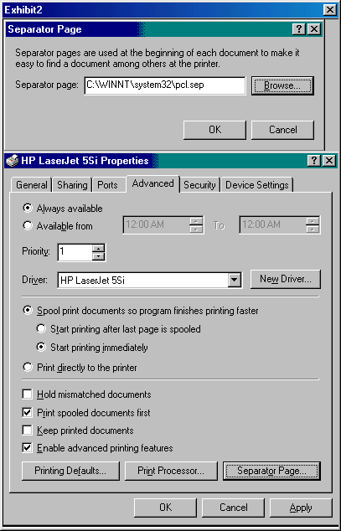
You assign the Attorneys group Modify permissions to the printer.

Which requirements are met by the actions? (Choose all that apply.)
- All letter-sized documents print to the lower tray
- All legal-sized documents print to the printer’s upper tray
- All members of the Attorneys group have the minimum permissions required to print to the printer
- The print mod is specified as PCL and a separation page is configured to print before printing each document

- You are in charge of upgrading 100 Windows NT 4.0 servers to Windows 2000 servers by implementing an unattended installation that meets the following requirements:

You must upgrade the existing software from Windows NT 4.0 to Windows 2000 Server.
You must copy the source files to the computer's F: drive.
You must specify the location for the L: drive as the drive for the network share since it contains the \I386 directory.
You must specify a reboot 15 seconds after copying files to continue setup.
You must specify the L: drive as the location for the unattend.txt file.

You take the following action:
On the Run line, you type:
Winnt32.exe /s:L:\I386 /unattend 15:L:\unattend.txt /tempdrive:F.

Which requirements does the command meet? (Choose all that apply.)
- The command copies the source files to the computer’s F: drive
- The command specifies the L: drive as the location for the unattend.txt file
- The command specifies a reboot 15 seconds after copying files to continue setup
- The command successfully upgrades the existing software from Windows NT 4.0 to Windows 2000 Server
- The command specifies the location for the L: drive as the drive for the network share since it contains the \I386 directory

- You are the administrator for your company's Windows 2000 domain. You have several Windows 2000 Server computers that have the Windows Internet Name Service (WINS) installed. Your WINS servers have both dynamic and static mappings.

Recently your NetBIOS name requests have experienced some problems. Upon investigation, you discover that some static WINS entries are causing problems for some dynamic entries.

In the Replication Partners Properties dialog box, you check the Enable Migrate box.

Which result does this action achieve?
- It scavenges the WINS database
- It enables WINS to overwrite static records with dynamic records
- It deletes all dynamic mappings and allows only static mappings from this point forward
- It deletes all static mappings and allow only dynamic mappings from this point forward

- You are the administrator for a Windows 2000 network that is configured for remote access (RAS), Active Directory, and Group Policies. The network uses only Windows 2000 Server computers and Windows 2000 Professional client computers.

You are making configuration changes to the user account properties. You decide to set the Always Callback To option in the Properties dialog box.

Why did you make this change?
- To enable dial-in settings
- To disable dial-in settings
- To specify the telephone number that the user must dial in to
- To specify that the RAS server calls back the user to a specified telephone number

- Your company has its central headquarters in downtown Los Angeles. It also has a small satellite office in the San Fernando Valley about thirty miles away. The satellite office only accepts payments. The main office has a Windows 2000 domain controller, two Windows 2000 member servers, and 75 Windows 2000 Professional workstations. The accounting software for the company runs completely on the domain controller. The satellite office has a single Windows 2000 Professional computer. You must configure the following functionality on the network:

The employee in the satellite office must post payments only on the corporate network's accounting software.
The connection to the corporate office from the satellite office must be very inexpensive.
The satellite office must connect to the network through the Internet.
Entire IP datagrams transferred from the satellite office to the corporate network must be encapsulated and encrypted to ensure data security.

You take the following actions:
You implement a Virtual Private Network (VPN) connection between the Windows 2000 domain controller and the Windows 2000 Professional workstation.
You assign the satellite office user the appropriate permissions to connect and use the accounting software.
You implement the VPN with the IPSec protocol using the ESP Tunnel Mode.
You use a dial-up ISP to form the connections on both sides.

Which requirements do the actions meet? (Choose all that apply.)
- The satellite office connects to the network through the Internet
- Entire IP datagrams are encapsulated and encrypted to ensure data security
- The connection to the corporate office from the satellite office is inexpensive
- The employee in the satellite office can post payments on the corporate network’s accounting software

- You are the administrator for a Windows 2000 Server network. The network contains a Windows 2000 native-mode domain. The server is set to use the default remote access policy.

You are setting up new user accounts on the domain. You want the Remote Access Permissions for the user accounts to be set to automatically allow access.

What should you do to ensure this setting?
- Do nothing. Allow access is the default setting
- Change the setting from Deny access to Allow access
- Change the setting from Deny remote access permission policy to Allow access
- Change the setting from Control access through Remote Access Policy to Allow access

- As the network administrator, you must upgrade three Windows NT 4.0 Server computers (1 PDC and 2 BDCs) to the Windows 2000 Server operating system. The current servers have Windows NT 4.0 RAID level 1 implementations. You must meet the following requirements during the upgrade process:

You must install the new operating system and implement a RAID level 1 configuration under Windows 2000.
You must upgrade to Windows 2000 using the company network.
You must upgrade a Windows NT 4.0 Workstation computer to Windows 2000 Server.
You must provide support on all servers so all distributed applications can use the HTTP protocol to communicate through Internet Information Services (IIS).

You take the following actions:
On the Windows NT 4.0 Server computers and the Windows NT 4.0 Workstation computers, you upgrade the servers by connecting to the network shared CD-ROM drive g:\i386\winnt32.exe.
On the Windows 2000 servers, you install the following optional components:
All Management and Monitoring tools
Microsoft Script Debugger
Remote Installation Services
Remote Storage
Networking Services- COM Internet Services Proxy
Internet Information Services (IIS).

Which requirements do the actions meet? (Choose all that apply.)
- The upgrade will take place using the company network
- The Windows NT 4.0 Workstation computer will be upgraded to Windows 2000 Server
- The RAID level 1 configuration will be in place in the Windows 2000 operating system
- Support is provided on all servers so all distributed applications can use the HTTP protocol to communicate through IIS

- You must back up the registry and all user data on a Windows 2000 Active Directory domain controller. How can you back up the appropriate files while minimizing the time the backup requires?
- Use Windows Backup to back up the System State Data
- Use Windows Backup to perform a full system back up
- Use Windows Backup to create a differential back up
- Use Windows Backup to create a backup of specified folders

- As the Windows 2000 Server administrator, you must configure the server's hard drive configuration. The Pentium III 500 MHz server with 256 MB of RAM has two 10-GB hard drives and a 1.6 GB hard drive. The hard drive configuration is as follows:

C:\- 2-GB FAT RAID Level 1 partition
D:\- 999-MB NTFS RAID Level 5 partition
E:\- CD-ROM
F:\- 500-MB FAT32 striped set
G:\- 13.66-GB FAT32 spanned volume

You must store all user data on the drive configuration that can recover if any single disk in the computer fails.
You must store the paging file on the disk configuration with the fastest write access.
You must store accounting data on the hard drive that can recover if either Disk 0 or Disk 1 fails.
You must store confidential data on the hard drive configuration that prevents unauthorized users from accessing information locally even though they have local access to the server.

The RAID configuration is shown here:

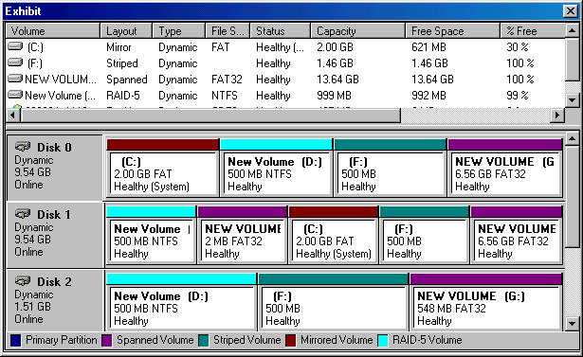

You take the following actions:
You store the user data on drive D:.
You store the paging file on drive G:.
You store the accounting data on drive C:.
You store the confidential data on drive D:.

Which data is properly stored on the computer by the actions? (Choose all that apply.)
- User Data
- Paging File
- Accounting Data
- Confidential Data

- After the installation of Windows 2000 Server, you notice that the dependency service fails to start. How can you resolve this error? (Choose two.)
- Verify the local computer name is unique to the network
- Verify the proper domain name is used during the installation
- Ensure the proper protocol and network adapter are configured in Network Settings
- Ensure the target partition has sufficient free space for the Windows 2000 Server installation

- You must install Windows 2000 on a new computer. The computer has four 20-GB disks. You must configure the system partition to be as large as possible on this Pentium III 667 MHz computer with 512 MB of RAM. For the remainder of the drive configuration, you want a single drive letter assigned to all the existing space. You do not want to implement any type of RAID configuration on the computer. How should you configure the system partition during the setup phase of Windows 2000?
- Configure the system partition as a 4-GB partition
- Configure the system partition as a 2-GB partition
- Configure the system partition as a 20-GB partition
- Configure the system partition as a 7.8-GB partition

- You are the Windows 2000 network administrator for a stock brokerage firm. The 65 stockbrokers on site use Windows 2000 Professional computers as their workstations, and there are two Windows 2000 domain controllers that serve these clients. Due to the sensitive nature of the information, your company policy requires all trade information to be stored on one of the two domain controllers. Each domain controller has five 10-GB hard drives on it. The user information is stored on a striped set of four of the hard drives, and the system uses the other hard drive. The striped set is backed up every evening. You must configure disk quotas as follows:

You must limit disk storage space to 300 MB.
An event must be logged when the users approach 95% of their used space.
You must allow the user to exceed the quota limit.
An event must be logged when the users exceed their specified quota limit.

You take the following actions:
You configure the quota as shown below:

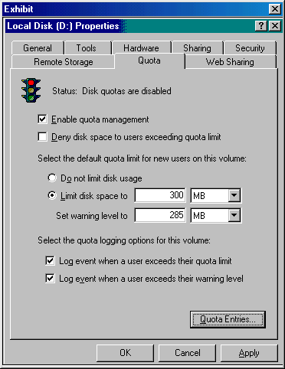

Which requirements are met by the quota configuration? (Choose all that apply.)
- Users can exceed their quota limit
- User disk space quota limits are 300 MB
- An event is logged when the user exceeds their quota limit
- An event is logged when the user exceeds 95% of their quota

- You are the administrator for a Windows 2000 network. The network consists of Windows 2000 Server computers and Windows 2000 Professional client computers. The network uses Active Directory with Group Policies. You want to begin the implementation of the Encrypting File System (EFS) on the network and client computers to encrypt all data files stored on the network.

You decide to use the Cipher command-line utility from a command prompt to encrypt a folder on one of the client computers. From the client computer, you open a command prompt screen. You want to encrypt the Administrator's My Documents folder on the C: drive of the client computer.

Which line will encrypt the folder?
- Cipher /a “C:\Documents and Settings\Administrator\My Documents”
- Cipher /a “C:\Documents and Settings\Administrator\My Documents”
- Cipher /h “C:\Documents and Settings\Administrator\My Documents”
- Cipher /k “C:\Documents and Settings\Administrator\My Documents”

- In Device Manager on your Windows 2000 server, you notice a red X next to the U.S. Robotics 56K Voice PCI modem. How can you resolve this problem using Device Manager?
- Right-click on the device and select Troubleshooter
- Right-click on the device, select Properties, and on the General tab of the device’s Properties page select Use This Device (enable) under the Device usage section of the page
- Using the left pane of the two-pane Device Manager display, right-click on Device Manager on Local Computer, select View, select Devices by Connection, and expand the IRQ section in the right pane
- Using the left pane of the two-pane Device Manager display, right-click on Device Manager on Local Computer, select View, select Resources by Connection, and expand the IRQ section in the right pane

- You must implement a 17,000-node network. The network will consist of forty Windows 2000 domain controllers, twenty Windows 2000 servers, 60 Hewlett Packard 5SI printers, and 17,000 Windows 2000 Professional workstations. Your company has been assigned an IP address of 136.18.32.0. You expect the network to double in size to approximately 34 subnets with 1000 nodes per subnet in the next two years. How should you configure the IP addressing structure to allow for this configuration?
- 136.18.32.0/20
- 136.18.32.0/22
- 136.18.32.0/24
- 136.18.32.0/26

- You administer a Windows 2000 network that uses Active Directory and Group Policies. The network uses only Windows 2000 Server computers and Windows 2000 Professional client computers. The network also uses the Encrypted File System (EFS) to encrypt and protect files and folders.

You are performing routine maintenance on some of the client computers. You need to ensure that the users are using file encryption properly. You want to display the encryption state of the files in the directory you are currently accessing.

How can you accomplish this using the Cipher command-line utility?
- Cipher
- Cipher /s
- Cipher /h *
- Cipher /h *.*

- As the network administrator of a Windows 2000 network, you must secure the E:\Confidential folder on your Windows 2000 domain controller. The domain controller has three 10-GB SCSI hard drives in it. The partitions are composed of a 10-GB NTFS partition (C:), a 5-GB RAID level 1 configuration (D:), and two 5-GB FAT32 partitions (E: and F:). You must encrypt all information in the E:\Confidential folder. How can you encrypt the folder?
- Right-click on the folder, select Properties, select Advanced from the General Tab, and ensure the “Folder is ready for Archiving” box is selected
- Right-click on the folder, select Properties, select Advanced from the General Tab, and ensure the “Encrypt contents to secure data” selection box is selected
- Right-click on the folder, select Properties, select Advanced from the General Tab, and ensure the “For faster searching allow Indexing Service to Index the folder” box is selected
- Convert the drive to an NTFS partition. Right-click on the folder, select Properties, select Advanced from the General Tab, and ensure the “Encrypt contents to secure data” selection box is selected

- Using Task Manager's Processes tab, you must monitor the following process settings:

The total processor time a process has used the processor since it started.
The ranking of a process which determines the order in which the process uses the processor.

Select the two boxes which will monitor the above information.

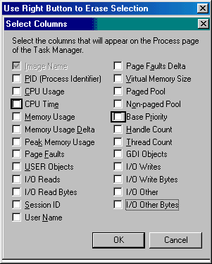
- You are installing a new network adapter for a Windows 2000 Server computer on the Windows 2000 network you administer. You complete the installation and install the device drivers.

Which function will notify you whether the driver you are installing passes the Microsoft certification process?
- Event Logs
- Driver Signing
- Device Manager
- Service Pack Slipstreaming

- You are the administrator of your Windows NT 4.0 network, and you must migrate the network to Windows 2000. The network has four Windows NT 4.0 servers. The servers have the configurations shown below:

Server_1 is a Pentium 200 MHz computer with 256 MB of RAM and a 2-GB FAT partition.
Server_2 is a Pentium III 350 MHz computer with 64 MB of RAM and a 10-GB NTFS partition.
Server_3 is a Pentium 100 MHz computer with 512 MB of RAM and a 6-GB NTFS partition.
Server_4 is a Pentium III 650 MHz computer with 2 GB of RAM and a 2-GB FAT partition.

You take the following actions to migrate to Windows 2000:
You type the Winnt32.exe command from the Run line of Server_1, Server_2, and Server_4.
You upgrade the processor of Server_3 to a Pentium 133 MHz processor and type the Winnt32.exe command from the Run line on the server.

Which computers will the actions upgrade properly? (Choose all that apply.)
- Server_1
- Server_2
- Server_3
- Server_4

- You are the administrator for a Windows 2000 network that uses Active Directory and Group Policies. The network consists of a DNS server. In addition, auditing is used to track events.

You are making configuration changes to the audit policy. You have decided to audit access to all files and folders on the C: drive.

How can you implement this change? (Choose two.)
- Enable the Audit Object Access policy
- In the audit policy, enable Audit Directory Service Access
- Enable auditing for all the files and folders on the C: drive
- Add an audit policy from the server for the computer containing the specific files and folders

- A hard disk fails in your Windows 2000 server. The disk was part of a RAID level 5 configuration. You replace the hard disk with an identical disk. How can you restore the RAID 5 volume?
- Reactivate the disk
- Recreate the volume
- No action is necessary
- Scan the volume for changes

- You must configure a process to use the maximum available resources on the computer to complete the task. How should you configure the process using Task Manager?
- Right-click the process, select Set priority, and select Low
- Right-click the process, select Set priority, and select High
- Right-click the process, select Set priority, and select Normal
- Right-click the process, select Set priority, and select Realtime

- You are the administrator of your Windows 2000 domain controller. The domain controller serves 65 Windows 2000 clients. During the day, there are always four programs running on the domain controller: your accounting software, your Exchange 5.5 service, Word 2000, and Outlook. You must monitor the server as follows:

You must monitor the amount of time the CPU is used by the operating system.
You must view the status of the running applications.
You must view the amount of time the CPU is used by each process.
You must view the percentage of the CPU a process is using at a given time.

You take the following actions:
In the Performance tab of Task Manager, you select View and then you select Show Kernel Times. You then view the amount of time the CPU is being used by the operating system.
In the Applications tab of Task Manager, you view the applications that are active on the domain controller and the status of those applications.
In the Processes tab of Task Manager, you view the amount of time each process uses the CPU and the percentage of the CPU a process is using at any given time.

Which requirements do the actions meet? (Choose all that apply.)
- You can successfully view the amount of time the CPU is used by each process
- You can successfully view the status of running applications on the domain controller
- You can successfully view the percentage of the CPU a process is using at a given time
- You can successfully monitor the amount of time the CPU is being used by the operating system

- You must add 4 Windows 2000 Server computers to your existing network. The network currently has 1 UNIX server, 25 Windows NT 4.0 servers, and 3 NetWare servers. There are 365 Windows 2000 Professional workstations, 400 Windows NT 4.0 Workstation computers, 600 Windows 98 computers, and 500 Windows 2000 laptop computers. You must configure the servers with the following requirements:

You must allow the UNIX server to print to a printer controlled by one of the Windows 2000 servers.
You must allow all client computers to access information on the NetWare servers.
You must configure the Windows 2000 servers so the laptop users can dial in to the network.
You must configure the Windows 2000 domain so it can still use the Windows NT 4.0 BDCs.

You take the following actions:
On all client computers, you install TCP/IP and NWLink.
On the UNIX server, you install an RFC-compliant Line Printer Remote (LPR) service.
On the Windows 2000 servers, you install Print Services for UNIX, the TCP/IP and NWLink protocols, and Gateway Services for NetWare (GSNW). In addition, you install Routing and Remote Access and configure it accordingly.
You configure the Windows 2000 servers to run in mixed mode.

Which requirements are met by the actions? (Choose all that apply.)
- The Windows 2000 domain can still use the Windows NT 4.0 BDCs
- The UNIX server can print to the Windows 2000 servers’ printers
- All client computers can access information on the NetWare servers
- The laptop users can dial in to the network via the Windows 2000 servers

- As the Windows 2000 network administrator, you must properly configure the domain controller's hard drive. You have just deleted a spanned volume on the Windows 2000 server, and the current drive configuration is below:

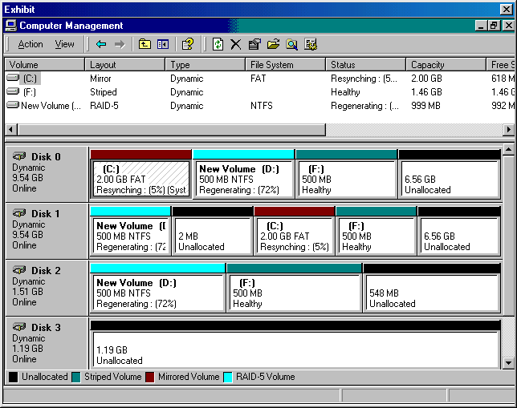

You are required to take this free space and configure it as follows:

You must create 3 GB of storage for a mission critical application and allow the entire 3 GB to be mirrored in case either Disk 0 or Disk 1 fails in the domain controller.
You must create a RAID level 5 configuration so there are 2 GB of space available for storage.
You must back up all volumes that are not fault tolerant.
You must use all remaining free space in a single volume.

You take the following actions:
You create a 3-GB RAID level 1 configuration using Disk 0 and Disk 1.
You create a RAID 5 volume using 1 GB of space on Disk 0, Disk 1, and Disk 3.
You back up disk F and implement a scheduled backup plan for it.
You use all the remaining free space on the disks to create a spanned volume.

Which requirements do the actions meet? (Choose all that apply.)
- The 3 GB mirrored volume is properly configured
- All remaining free space is used in a single volume
- All volumes that are not fault tolerant are backed up
- The RAID level 5 configuration is properly configured

- Due to strict security limitations of your Windows 2000 production environment, you must prevent any unsigned drivers from being installed on any computer in your Windows 2000 network. The network consists of Windows 2000 domain controllers, Windows 2000 file and print servers, and Windows 2000 Professional computers. How can you prevent the installation of any unsigned drivers on all the computers on your network?
- Implement a Group Policy to Ignore signature verification
- Configure a Local Policy on the main Windows 2000 domain controller
- Configure the domain controllers, file and print servers, and client computers to Block unsigned drivers
- Configure the domain controllers, file and print servers, and client computers to Ignore unsigned drivers

- You are the administrator for a Windows 2000 network. The network consists of Windows 2000 Server computers and Windows 2000 Professional client computers. The network is configured to use Active Directory and auditing.

You perform regular maintenance on the network. You like to periodically use the Event Viewer to check the success or failure of events that have auditing enabled.

What do you use to monitor these events?
- System log
- DNS Server
- Security log
- Application log
- Directory Service
- File Replication Service

- You must take a Windows 98 Pentium III 550 MHz computer and make it a Windows 2000 domain controller. After installing the Windows 2000 operating system, you install a USB scanner on the computer while it is on. How can you force Windows 2000 to search for a new scanner?
- Restart the computer
- Log off and back on to the domain controller
- Right-click on the domain controller’s name in Device Manager and select “Scan for hardware changes”
- This is not possible because Windows 2000 domain controllers do not support adding hardware while the computer is on

- You must take a Windows 98 Pentium III 550 MHz computer and make it a Windows 2000 domain controller. After installing the Windows 2000 operating system, you install a USB scanner on the computer while it is on. How can you force Windows 2000 to search for a new scanner?
- Restart the computer
- Log off and back on to the domain controller
- Right-click on the domain controller’s name in Device Manager and select “Scan for hardware changes”
- This is not possible since Windows 2000 domain controllers do not support adding hardware while the computer is on

- Your existing TCP/IP network has an address of 194.194.194.0. The network consists of 2 subnets with 60 nodes on one segment and 40 nodes on the other segment. All nodes are either Windows 2000 servers, Windows 2000 Professional computers, or HP 8000 printers using JetDirect cards. There are 3 Windows 2000 domain controllers. You must configure the network as follows:

You must properly subnet your network address.
You must configure the Windows 2000 Professional computers so they are automatically configured with a valid IP address.
You must minimize human error when configuring the computers with the networking information.
You must configure the client computers so they can be moved to another subnet without any modifications.

You take the following actions:
You use the subnet of 194.194.194.0/26.
You configure all Windows 2000 Professional computers as WINS clients.
You configure all Windows 2000 domain controllers as WINS servers and properly configure them.

Which requirements do the actions meet?
- The network is properly subnetted
- The client computer can be moved to another subnet without any modifications
- Human error is minimized when configuring the computers with the networking information
- The Windows 2000 Professional client computers are automatically configured with a valid IP address

- You are the administrator for a Windows 2000 network. The network consists of all Windows 2000 Server and Windows 2000 Professional computers. You need to perform auditing maintenance. You want to accomplish the following goals:

Track successful attempts to create folders.
Track failed attempts to create files.
Track successful attempts to write attributes.
Track failed attempts to read folder permissions.

You perform the following actions:

Open the Properties dialog box for a specific folder.
Select the Security tab and click the Advanced button.
Select the Auditing tab and add an entry with permissions set as indicated below:

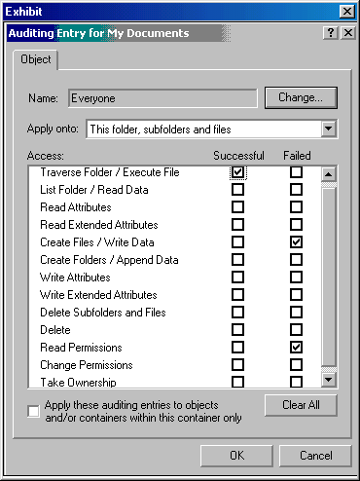

Which goal or goals are accomplished by these actions? (Choose all that apply.)
- Track failed attempts to create files
- Track failed attempts to create folders
- Track successful attempts to write attributes
- Track failed attempts to read folder permissions

- As the network administrator, you must upgrade 3 Windows 98 computers to the Windows 2000 Server operating system. The Windows 98 computers are Pentium III 550 MHz computers with 256 MB of RAM, but they do not have a CD-ROM in them. You must perform an over-the-network install of the operating system. How can you perform this function?
- Share the installation folder. Boot the computers with an MS-DOS network boot disk.
- Share the installation folder. Boot the computers with a Windows 98 network boot disk.
- Share the installation folder. Upgrade the new operating system using the Winnt.exe command.
- Share the installation folder. Migrate to the new operating system using the Winnt32.exe command from the Run line of Windows 98

- You are administering a Windows 2000 network for your company. The network consists of Windows 2000 Server and Windows 2000 Professional computers. The network is configured for Active Directory and includes a DNS server.

You are making routine configuration changes to the network. You are using the Security Configuration and Analysis snap-in.

Which tasks can you perform using this snap-in? (Choose all that apply.)
- Track events
- Create group policies
- Set a working database
- Import a security template

- You are the administrator for a Windows 2000 network. The network is configured with Active Directory and Group Policies. Only Windows 2000 Server and Windows 2000 Professional computers are used on the network.

You need to make some group policy configuration changes. You create a group policy object (GPO) linked to an Organizational Unit (OU). You do not want the GPO to use any policies from the domain.

How can you accomplish this task?
- Check the “Block Inheritance” box in the main screen of the OU’s Group Policy Editor
- Check the “Apply Group Policy” box in the main screen of the domain’s Group Policy Editor
- Check the “Delete All Child Objects” box in the domain GPO policy’s Properties dialog box
- Check the “No Override” box in the OU GPO’s Options dialog box within the Properties dialog box

- You are administering a Windows 2000 network. The network uses a DHCP server. The network contains Windows 2000 Server and Windows 2000 Professional computers.

You are implementing DHCP leasing on new client computers. While testing the configurations, TCP/IP is initialized for the first time. This starts the DHCP lease process.

What is the first step in this process?
- DHCPACK
- DHCPNACK
- DHCPOFFER
- DHCPREQUEST
- DHCPDISCOVER

- You must configure a client's subnet mask and default gateway. All subnets on the network use a /24 subnet addressing scheme. The router that connects the subnet to the network has an IP address of 158.25.64.1. The next router in line has an IP address of 158.23.65.2. Which subnet mask and default gateway should you use to configure the client computer?
- 255.255.0.0
158.25.64.1
- 255.255.0.0
158.23.65.2
- 255.255.255.0
158.25.64.1
- 255.255.255.0
158.23.65.2

- You are administering a Windows 2000 network. The network uses Active Directory and Group Policies. The network consists of a DNS server and uses auditing to track events.

You are making configuration changes to the audit policy. You have decided to enable auditing for an additional event. After making the change, how will it begin to take effect? (Choose all that apply.)
- By restarting the computer
- By typing Secedit at a command prompt
- From a regularly scheduled policy propagation
- By logging off and logging on to the computer
- By typing RefreshPolicy machine_policy at a command prompt

- You are the administrator for your company's Windows 2000 domain. Your network consists of a Windows 2000 Server Primary Domain Controller (PDC) and 200 Windows 2000 Professional client computers. The network uses static IP addresses. The network connects to the Internet over a T1 line, as shown below:

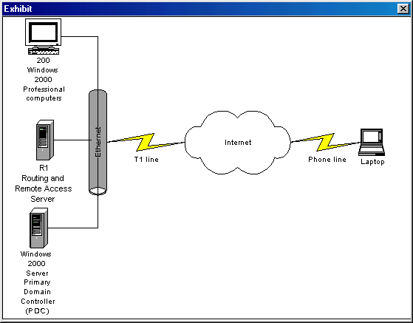

You set up a Routing and Remote Access Server, named R1, on your domain to allow access to your Virtual Private Network (VPN) resources.

Your company's salesmen use laptop computers while on the road. One of the salesmen can connect to the Internet through a local ISP and wants to connect to the company VPN. After configuring all of the appropriate components, he informs you that he cannot communicate with the VPN.

From a Windows 2000 Professional client computer on the domain, you ping R1 and receive a reply. You then discover that another computer on the domain has the same IP address as R1. How might you have discovered this problem?
- By using the RSH utility
- By using the Netsh utility
- By using the Telnet utility
- By using the IPCONFIG utility

- You have four 10-GB disks in your Windows 2000 server. You are trying to provide the maximum usable space while still providing for redundancy in case a single disk in the drive fails. How should you configure the hard drives to meet these requirements?
- Create two Raid Level 1 volumes
- Create two Raid Level 5 volumes
- Use all four disks to create a single RAID level 5 volume
- Use all four disks to create a single RAID level 1 volume

- As the Windows 2000 network administrator, you must enforce quota limits on disk storage space on the Windows 2000 domain controller. The domain controller has 3 GB of space for user storage, and there are only about 15 users that store information on the server. You must meet the following requirements:

You must enforce disk quota limits on your account, but you must still be able to install applications on the server without this space being added to your disk quota limit.
You need to be able to monitor usage of the free space so you can know when you need to modify the server’s hardware configuration. In monitoring this, you must not prevent any user from saving data.
You must delete several users from the volume since they are no longer employed by your company.
You must log an event when a user exceeds their quota limit.

You take the following actions:
In your day to day activities you use your user account, but when you add applications to the server, you log on as the administrator.
You ensure the "Deny Disk Space to Users Exceeding Quota Limit" check box is cleared.
You delete or transfer ownership to another user for all files owned by the former employees and then delete their quota entries.

Which requirements do the actions meet? (Choose all that apply.)
- An event is logged when a user exceeds their quota
- You successfully delete the former employees’ quotas
- Applications installed using the Administrator account will not be charged to your quota limit
- You can monitor the usage of free space so you can plan for hardware modification without preventing users from saving data

- In Device Manager on your Windows 2000 server, you notice a yellow question mark next to the Realtek RTL8139 PCI Fast Ethernet NIC. You suspect the problem is due to an IRQ conflict. How can you troubleshoot the problem with this device using Device Manager?
- Right-click on the device and select Troubleshooter
- Right-click on the device, select Properties, and on the General tab of the device’s Properties page, select Troubleshooter
- Using the left pane of the two-pane Device Manager display, right-click Device Manager on the Local Computer, select View, select Devices by Connection, and expand the IRQ section in the right pane
- Using the left pane of the two-pane Device Manager display, right-click Device Manager on the Local Computer, select View, select Resources by Connection, and expand the IRQ section in the right pane

- You must implement a 250-node network. You must divide the network into 2 subnets and each subnet must not exceed 125 nodes. How should you configure the IP addressing structure to allow for this configuration if the company's IP address is 194.194.194.0?
- 194.194.194.0/25
- 194.194.194.0/26
- 194.194.194.0/27
- 194.194.194.0/28

- You are the administrator for a Windows 2000 network. The network consists of Windows 2000 Server computers and Windows 2000 Professional client computers. The network also uses a DHCP server.

You are testing the DHCP lease process between the DHCP clients and the server. You receive a broadcast of a DHCPNACK on the DHCP client.

When does this broadcast take place?
- After the DHCPOFFER message is broadcast
- After the DHCPREQUEST message is broadcast
- When a client attempts to lease its previous IP address, and the IP address is not longer available
- When the IP address is invalid because the client computer was moved to a different location within the subnet

- You administer a domain on a Windows 2000 network. The network uses Active Directory, and contains a DNS server. The network consists of all Windows 2000 Server computers and Windows 2000 Professional client computers.

You have decided to implement roaming user profiles. You came to this conclusion based on numerous complaints from users that wanted to access their files and folders from different computers.

Which steps must you take to accomplish this task? (Choose two.)
- Create a shared folder on a server
- Create a read-only folder on a server
- Create a non-shared folder on a server
- From the Profile tab in the Properties dialog box of the user accounts, enter the path to a shared folder
- From the Profile tab in the Properties dialog box of the user accounts, enter the pat to a read-only folder
- From the Profile tab in the Properties dialog box of the user accounts, enter the path to a non-shared folder

- You must upgrade a Windows NT 4.0 Workstation computer to the Windows 2000 Server operating system. Once the upgrade is complete, you must implement a RAID level 5 configuration and you must provide support on the upgraded server so all distributed applications can use the HTTP protocol to communicate through Internet Information Services (IIS). How can you configure the server so Windows 2000 Server is the only operating system on the computer? (Choose all that apply.)
- Install Windows 2000 Server by connecting to the shared CD-ROM using the F:\i386\Winnt32.exe command. Then implement RAID level 5 on the server.
- On the Windows 2000 server, install the following optional components:
All Management and Monitoring tools
Microsoft Script Debugger
Remote Installation Services
Remote Storage
Networking Services- COM Internet Services Proxy.
- On the Windows 2000 server, install the following optional components:
All Management and Monitoring tools
Microsoft Script Debugger
Remote Installation Services
Remote Storage
Networking Services- COM Internet Services Proxy
Internet Information Services (IIS).
- Format the hard drive of the workstation. Install a client so you can obtain access to a network shared CD-ROM, install Windows 2000 Server by connecting to a shared CD-ROM using the F:\i386\Winnt.exe command. Then, implement a RAID level 5 configuration on the server.

- Your network has a Windows 2000 Active Directory server and a UNIX server. You must allow the UNIX server to print to a printer connected to the Active Directory server. How must you configure the network adapter on the LAN connection so this functionality is allowed on the Active Directory server? (Choose all that apply.)
- Install the DLC protocol
- Install Print Services for UNIX
- Install TCP/IP
- Install Client for Microsoft Networks
- Install File and Print Sharing for Microsoft Networks

- You are the administrator for a Windows 2000 network. The network is configured to use Active Directory and Group Policies. The network contains a DNS server and DHCP server.

You need to make changes to the security configurations stored in the network. These configurations are stored in security templates on the domain controller.

What can you access to make these changes?
- Security Templates snap-in
- Security Configuration and Analysis snap-in
- Active Directory Sites and Services snap-in
- Active Directory Users and Computers snap-in

- You must back up the Registry, the COM+ Class Registration database, the system boot files, the Certificate Server database, the Active Directory Services database, and the SYSVOL directory on a Windows 2000 Active Directory domain controller. The domain controller is a Pentium 200 MHz with a RAID 5 array composed of ten 3-GB partitions. How can you back up the appropriate files while minimizing the time the backup takes?
- Use Windows Backup to perform a full system backup
- Use Windows Backup to create a differential backup
- Use Windows Backup to back up the System State Data
- Use Windows Backup to create a backup of specified folders

- You are administering a Windows 2000 network. The network consists of Windows 2000 Server computers and Windows 2000 Professional client computers.

You need to configure some settings for the network adapter in one of the server computers. You want to use the tools that Windows 2000 provides for managing the device.

Where can most of these tools be found?
- The General tab of the System Properties dialog box
- The Advanced tab of the System Properties dialog box
- The Hardware tab of the System Properties dialog box
- The Network Identification tab of the System Properties dialog box

- You are the administrator for a Windows 2000 network that uses Windows 2000 Server computers and Windows 2000 Professional client computers. The network is configured to use Active Directory and Group Policies.

You find out that one of the Windows 2000 Server computer's local group policy settings is incorrect according to your company's standards. The administrator before you changed the permissions for the local group policy. You want the permissions set back to the defaults.

Where will you access these permissions and how should the permissions be set?
- Use the WINNT\System directory, and set the permissions to:
Administrators = Read, Write, and Modify
SYSTEM = Full Control
Authenticated Users = List Folder Contents.
- Use the WINNT\System32 directory, and set the permissions to:
Administrators = Read, Write, and Modify
SYSTEM = Full Control
Authenticated Users = Read, and List Folder Contents.
- Use the WINNT\System directory, and set the permissions to:
Administrators = Full Control
SYSTEM = Read, Write, and Modify
Authenticated Users = Read and Execute, and List Folder Contents.
- Use the WINNT\System32\GroupPolicy directory, and set the permissions to:
Administrators = Full Control
SYSTEM = Full Control
Authenticated Users = Read and Execute, List Folder Contents, and Read.

- As the network administrator, you create an Organizational Unit (OU) with a child OU named ENGUSERS. The child object must have explicit rights assigned to it, but the OU's permissions must propagate to the OU and all its other child objects. How can you configure this functionality on the Active Directory-enabled Windows 2000 server? (Choose all that apply.)
- Configure permission inheritance on the OU
- Configure permission inheritance on the OU and all child objects
- On the child object with explicit rights, use the Security tab and clear the check box to Allow Inheritable Permissions From Parent to Propagate To This Object
- On the child object with explicit rights, use the Security tab and select the check box to Allow Inheritable Permissions from Parent to Propagate To This Object

- Your Windows 2000 server has 2 IDE 15-GB hard drives in it. Each drive has 3 partitions on it. The system partition is the first partition on the first hard drive and it is replicated to the second partition on the second drive using a RAID level 1 configuration. The first hard drive fails and you must edit the Boot.ini file so the system partition uses the replication on the second disk. How should you configure the ARC path?
- multi(0)disk(0)rdisk(1)partition(2)\WINNT=”Windows 2000 Server”
- multi(0)disk(0)rdisk(2)partition(2)\WINNT="Windows 2000 Server"
- multi(0)disk(0)rdisk(2)partition(3)\WINNT="Windows 2000 Server"
- multi(0)disk(0)rdisk(1)partition(3)\WINNT="Windows 2000 Server"

- As the Windows 2000 network administrator, you must optimize disk space on your Windows 2000 domain controller. There are some folders that must be compressed. You must compress the C:\Operations folder and the D:\Aged Accounts folder. The C: partition is an NTFS partition and the D: partition is a FAT32 partition. How can you compress the folders? (Choose two.)
- Right-click on the C:\Operations folder in Explorer and select Properties. On the General Tab, you select Advanced, then you select the check box to "Compress contents to save disk space".
- Right-click on the D:\Aged Accounts folder in Explorer and select Properties. On the General Tab, you select Advanced, then you select the check box to "Compress contents to save disk space".
- Convert the D: partition to NTFS, right-click on the D:\Aged Accounts folder in Explorer and select Properties. On the General Tab, you select Advanced, then you select the check box to "Compress contents to save disk space".
- Format the D: partition, restore the folder from backup, right-click on the D:\Aged Accounts folder in Explorer and select Properties. On the General Tab, you select Advanced, then you select the check box to "Compress contents to save disk space".

- You are the administrator for a Windows 2000 network that uses only Windows 2000 Server computers and Windows 2000 Professional client computers. Your company uses the Encrypted File System (EFS) to encrypt files and folders on the network.

You have just installed a new Windows 2000 Professional client computer for a new employee. You need to create a new file encryption certificate on the computer.

Using the Cipher command-line utility, which line will accomplish this task?
- Cipher /k
- Cipher /f
- Cipher /e
- Cipher /f /q

- Your company plans to establish a new Web site. This Web site will allow visitors to download various shareware programs from your FTP site. The network administrator will be responsible for managing the FTP traffic to the site.

Which optional component should you install?
- Remote Storage
- Windows Media Services
- Remote Installation Services
- IIS

- You are the administrator of your Windows 2000 domain controller. The domain controller's hard drive configuration is shown below:

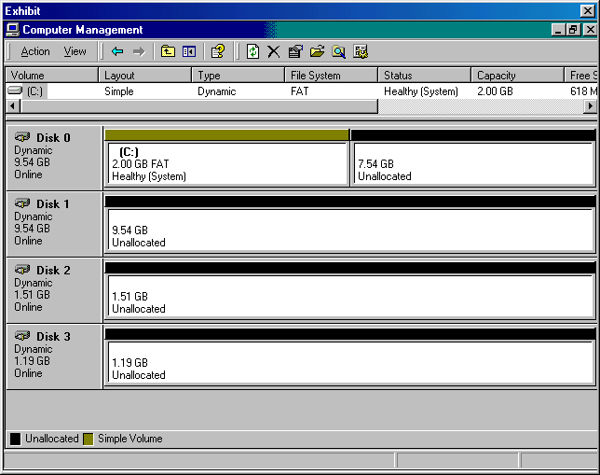

You must configure the hard drives in the server as follows:

You must protect the system partition by creating an exact duplicate of it so if one of the hard drives fails, the system information is still protected.
You must create a disk configuration that has approximately 6 GB of usable hard disk space, and can recover in the event one of the hard drives fails.
You must create a 3-GB disk configuration where you can allow the fastest Read access to the drive possible.
You must create 2 GB of usable space in a RAID level 1 configuration.

You take the following actions:
You mirror the system partition using 2 GB of space from Disk 1.
You create a RAID level 5 configuration using 2 GB of disk space from Disk 0, Disk 1, and Disk 2.
You create a striped set using 1 GB from Disk 0, Disk 1, and Disk 3.
You create a mirrored set using 1 GB of space from Disk 0 and Disk 1.

Which requirements do the actions meet? (Choose all that apply.)
- A disk configuration is created so 2 GB of usable space is used in a RAID level 1 configuration
- A 3-GB disk configuration is created where you can allow the fastest write access to the drive possible
- A disk configuration is created that has approximately 6 GB of usable hard disk space and can recover in the event one of the hard drives fails
- The system partition is protected by creating an exact duplicate of itself so if one hard drive fails the system information will still be protected

- You are a network administrator for your company's Windows 2000 Server network. The network contains a remote access server with dial-in access enabled.

You need to set the profile properties for the default remote access policy. You want to accomplish the following goals:

Disconnect client sessions if the dial-in client is idle for 15 minutes.
Limit client sessions to three hours.
Limit client system access times to Monday through Friday, 7:00 a.m. to 6:00 p.m.
Limit clients to Async modem access.

You perform the following actions:

From the Routing and Remote Access console, you double-click your remote access server.
You open the Properties dialog box for the default remote access policy.
You click the Edit Profile button.
You make the changes as shown below:

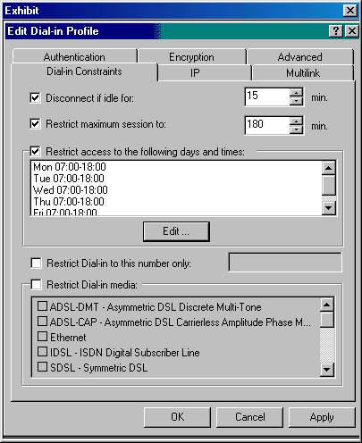

Which goal or goals are accomplished from these actions? (Choose all that apply.)
- Limit clients to Async modem access
- Limit client sessions to three hours
- Disconnect client sessions if the dial-in client is idle for 15 minutes
- Limit client system access times to Monday through Friday, 7:00am to 6:00pm

- As the network administrator of a Windows 2000 network, you must optimize disk performance on five Windows 2000 domain controllers. Each domain controller has five 6-GB SCSI hard drives in them. In addition to the five domain controllers, there are 600 Windows 2000 Professional computers on the network. Your network is a 100BaseT network. You must optimize the domain controllers as follows:

You must implement a plan for optimizing the data on the hard drives at the recommended Microsoft interval so application initialization is optimized.
You must compress all user store information that is located in the main D:\User_info folder.
You must provide fast searching capabilities for the D:\Data and E:\Marketing folders.
You must prevent users from exceeding 50 MB of storage on any single disk in a domain controller.

You take the following actions:
You implement a defragmentation plan the first Sunday of the month on all domain controllers.
You configure the folder compression as shown below:

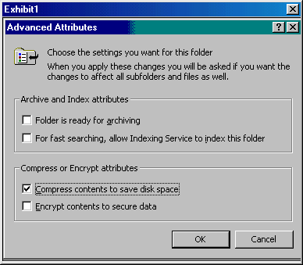

You configure the searching capabilities on the two folders as shown above, except you clear the "Compress contents to save disk space" check box, and you select the "For faster searching allow Indexing Service to Index the folder."
You implement disk quotas as below with Local Disk (D:) Properties at the top on all the disks in all the domain controllers.

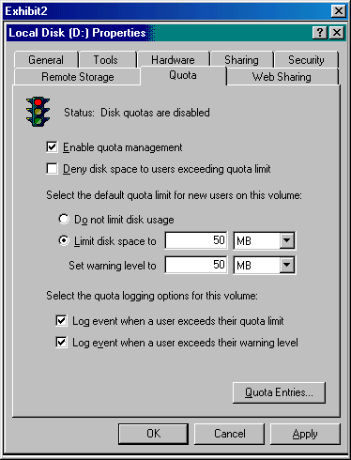

Which requirements do the actions meet? (Choose all that apply.)
- All user store information located in the main D:\User_info folder is compressed
- The Microsoft recommended plain is implemented to optimize application initialization time
- Fast searching capabilities for the D:\Data and E:\Marketing folders are properly provided
- Users are prevented from exceeding 50 MB of storage on any single disk in a domain controller

- As the Windows 2000 network administrator, you must optimize disk space on your Windows 2000 domain controller. There are some folders that must be encrypted. The C: volume in the domain controller is an NTFS volume and is fault tolerant. You must configure the C:\Accounting, C:\Marketing, C:\Downloads, and C:\My Documents folder as follows:

You must compress the C:\Downloads folder so it requires less disk space.
You must compress and encrypt the C:\Marketing folder.
You must encrypt the C:\My Documents folder.
You must encrypt the C:\Accounting folder.

You take the following actions:
You right-click on the C:\Downloads folder in Explorer and select Properties. On the General Tab, you select Advanced, then you select the check box to "Compress contents to save disk space".
You right-click on the C:\Marketing folder in Explorer and select Properties. On the General Tab, you select Advanced, you select the check box to "Compress contents to save disk space", and the check box to "Encrypt contents to secure data".
You right-click on the C:\My Documents folder in Explorer and select Properties. On the General Tab, you select Advanced, then you select the check box to "Encrypt contents to secure data".
You right-click on the C:\Accounting folder in Explorer and select Properties. On the General Tab, you select Advanced, then you select the check box to "Encrypt contents to secure data".

Which folders are properly configured? (Choose all that apply.)
- C:\Downloads
- C:\Marketing
- C:\Accounting
- C:\My Documents

- You are the administrator of your company's Windows 2000 network. One of the Windows 2000 Server domain controllers needs its hardware upgraded to keep up with company standards. You need to upgrade the 10BaseT network card to a 100BaseT network card. In addition, you need to add a 3D sound card, a modem, and a Super VGA video card to your domain controller for videoconferencing capabilities. The domain controller's motherboard has an on-board video card and sound card.

The new video card is not on the Hardware Compatibility List (HCL), but you need to use it.
The new sound card is on the HCL.
The new network adapter is not on the HCL.
The new modem is on the HCL.

You take the following actions to install the software properly:
You configure driver-signing options as below:

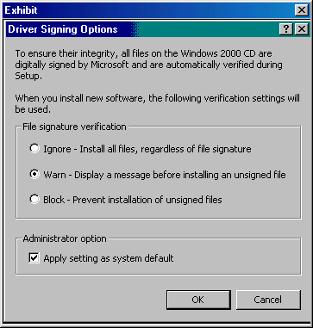

You disable the on-board sound card and video card.
You physically install the hardware into the computer.
You boot the domain controller and install the appropriate drivers.

Which devices will function properly in the domain controller? (Choose all that apply.)
- Modem
- Sound card
- Video card
- Network adapter

- While administering a Windows 2000 network, you and your co-workers decide to implement roaming user profiles for all users on the network. The network uses only Windows 2000 Server computers and Windows 2000 Professional client computers.

In addition to implementing the roaming user profiles, you have decided to implement home folders on the network for the users. When creating the home folders, which permission change is required?
- The permissions on the folder must be changed from Full Control for the Everyone group to Full Control for the Users group.
- The permissions on the folder must be changed from Full Control for the Users group to Full Control for the Everyone group.
- The permissions on the folder must be changed from Write Permissions for the Everyone group to Write Permissions for the Users group.
- The permissions on the folder must be changed from Write Permissions for the Users group to Write Permissions for the Everyone group.

- You are the administrator for a Windows 2000 network. The network uses Terminal Services.

You have decided to deploy applications to the client computers from the domain controller. You have discovered that the original application installation package did not install all of the necessary components to the local disk. What do you need to use in deploying the application from the domain controller?
- target file
- transform file
- installation file
- initialization file

- You are the administrator of a Windows 2000 network. The network has 5 Windows 2000 domain controllers, 17 Windows NT 4.0 servers, 6 NetWare 5.1 servers, and 3 UNIX servers. It also has 600 Windows 95 workstations, 800 Windows 98 workstations, 200 Windows 2000 Professional workstations, and 1500 Windows NT 4.0 workstations. The network uses Microsoft Exchange as its e-mail server and all clients use Outlook 98 as the e-mail client. You have installed Microsoft Exchange on one of the Windows 2000 domain controllers in the volume of the server that provides the best overall performance. Your Exchange server crashes and you look at the domain controller’s drive configuration:

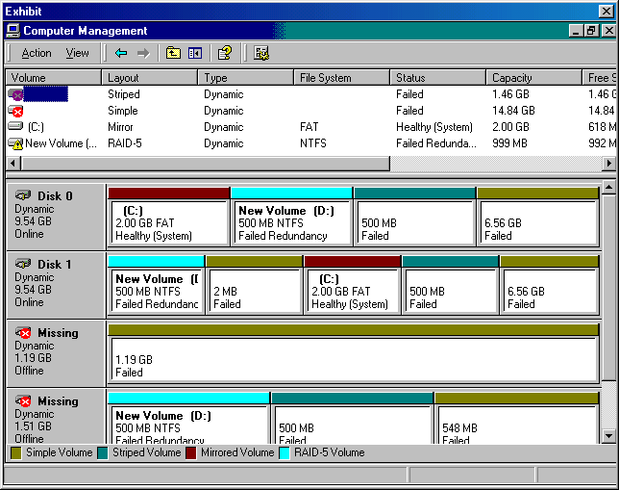

You must meet the following requirements:
You must restore the Exchange information and get the server back up immediately.
You must restore the information on the other hard drive configuration that has failed.
You must replace the failed hard drives.
You must put the server back in the original working order.

You take the following actions:
You install a 1.19-GB hard disk and a 1.51-GB hard disk into the server.
You remove the striped volume and the spanned volume.
You recreate the striped volume and spanned volume exactly as they were originally.
You restore the Exchange backup to the spanned volume.
You restore the backup from the spanned volume into the new spanned volume.

Which requirements do the actions meet? (Choose all that apply.)
- The failed hard drives are replaced
- The information on the other hard drive is successfully restored
- The server is back in the original working order after the actions
- The Exchange information is successfully restored to its original location

- You are configuring Group Policy for your Windows 2000 network. The network uses only Windows 2000 Server computers and Windows 2000 Professional client computers.

You want to create a group policy. You want the policy linked to a site. You must first create a group policy object (GPO).

How can you accomplish this task?
- Open the Active Directory Sites and Services snap-in. Select the site and open the Properties dialog box. Select the Object tab and enter the object name.
- Open the Active Directory Users and Computers snap-in. Select the Users node and open the Properties dialog box for Group Policy Creator Owners. Enter a name for the new GPO.
- Open the Active Directory Sites and Services snap-in. Select the site and open the Properties dialog box. Select the Group Policy tab and click New. Enter a name for the new GPO.
- Open the Active Directory Users and Computers snap-in. Select the site and open the Properties dialog box. Select the Group Policy tab and click New. Enter a name for the new GPO.

- You have recently been hired as one of the network administrators for a Windows 2000 network. The network uses Active Directory and Group Policies, and consists of all Windows 2000 Server computers and Windows 2000 Professional client computers.

You have been training for your new position with one of the administrators. While observing maintenance procedures, the administrator uses the utility Gpedit.msc.

Why did the administrator use this utility?
- To edit the local GPO
- To edit the domain GPO
- To create a new local GPO
- To create a new domain GPO

- After the installation of Windows 2000 Server, the server fails to start and you receive a blue screen error. How can you resolve this error?
- Increase the amount of memory in the server
- Verify all hardware is properly detected an on the HCL
- Create enough free space for the Windows 2000 Server installation on the target partition
- Replace the CD-ROM drive with one that is on the Windows 2000 Hardware Compatibility List

- You want to perform an installation of Windows 2000 Server on three new computers. You must meet the following requirements:

The installation must be performed over the network.
The users must not be able to change any installation options.
The users must be able to use the Recovery Console after installation.
You must specify an optional folder named INSTALL to be installed and not removed with the temporary files after the installation.

You take the following action:
On the Run line, you type:
Winnt32.exe /s:L:\I386 /u:\unattend.txt /r:INSTALL.

Which requirement does the command meet?
- The installation is performed over the network
- The actions do not meet any of the requirements
- The users cannot change any installation options
- The users can use the Recovery Console after installation
- The optional folder named INSTALL is installed and not removed with the temporary files after the installation

- Your company has recently hired you to be the Windows 2000 network administrator. The network uses a DHCP server and Terminal Services.

You must install a new network card in one of the Windows 2000 Server computers. You must then configure properties and settings after the installation of the device and the device drivers.

What is the best way to accomplish this task?
- Use the Installation CD
- Manually configure the settings
- Allow Windows 2000 to configure the settings
- Copy the settings from another network adapter

- You are the administrator for a Windows 2000 network. The network is configured for Active Directory and Group Policies.

You want to implement auditing on the network. You have enabled access to Active Directory objects. You now need to enable auditing for specific Active Directory objects.

What must you access to enable these objects?
- Event Viewer snap-in
- Security Configuration and Analysis snap-in
- Active Directory Sites and Services snap-in
- Active Directory Users and Computers snap-in

- You must connect a satellite office to the main office network using the Internet. At the main office, you will connect to a Windows 2000 server using a Windows 2000 Professional computer from the satellite office. How should you make the connection using the most secure method over the Internet?
- Implement a VPN connection with the IP in IP (IP-IP) protocol
- Implement a VPN connection with the Point-to-Point Tunneling Protocol
- Implement a VPN connection with the Layer 2 Tunneling Protocol
- Implement a VPN connection with the PPTP protocol using IPSec Encapsulating Security payload Tunnel Mode

- You are the administrator for your company's Windows 2000 network. The network consists of Windows 2000 Server computers and Windows 2000 Professional client computers. The network uses the Encrypting File System (EFS) to encrypt data files and folders.

You are setting up encryption on some files of a user's computer. You want to achieve the following goals:

Encrypt the data in the My Documents folder.
Configure the My Documents folder to be archived.
Configure the My Documents folder to be indexed.
Compress the data in the My Documents folder.

You perform the following actions:

You select the My Documents folder, right-click, and open the Properties dialog box.
You click the Advanced button to open the Advanced Attributes dialog box.
You check the "Folder is ready for archiving" box.
You check the "For fast searching, allow Indexing" box.
You check the "Encrypt Contents To Secure Data" box.
You close the dialog boxes.

Which goal or goals are accomplished from these actions? (Choose all that apply.)
- Encrypt the data in the My Documents folder
- Compress the data in the My Documents folder
- Configure the My Documents folder to be indexed
- Configure the My Documents folder to be archived

- As the network administrator, you must upgrade 3 Windows 3.1 workstations to the Windows 2000 Server operating system. The workstations meet the minimum hardware requirement for installing Windows 2000 Server, but they do not have a CD-ROM in them. You must perform an over-the-network install of the operating system. You must also partition the hard drive in the computer so it is 2 GB and not the existing 1 GB. How can you perform this function? (Choose three.)
- Boot the computers with a Windows 95 boot disk
- Boot the computers with an MS-DOS network boot disk
- Install the new OS using the Winnt.exe command
- Fdisk the drive, delete the partition, and create a new 2 GB primary partition
- Migrate to the new operating system using the Winnt32.exe command from the Run line of Windows 3.1
- Fdisk the drive, delete the partition, create a new 2 GB primary partition and format the new partition

- You are administering a Windows 2000 network that uses Windows 2000 Server computers and Windows 2000 Professional client computers.

You need to make some configuration changes to the hardware profiles for one of the server computers.

What should you access to accomplish this task?
- System in Control Panel
- Power Options in Control Panel
- Add/Remove Hardware in Control Panel
- Network and Dial-Up Connections in Control Panel

- You are configuring Group Policy for your Windows 2000 network. The network uses only Windows 2000 Server computers and Windows 2000 Professional client computers.

You want to create a group policy. You want the policy linked to a domain. You must first create a group policy object.

What do you access to accomplish this task?
- Services snap-in
- Security Configuration And Analysis snap-in
- Active Directory Sites and Services snap-in
- Active Directory Domains and Trusts snap-in
- Active Directory Users and Computers snap-in

- You must implement a 200-node network. You must divide the network into 4 subnets and each subnet must not exceed 60 nodes. How should you configure the IP addressing structure to allow for this configuration if the company's IP address is 194.194.194.0?
- 194.194.194.0/25
- 194.194.194.0/26
- 194.194.194.0/27
- 194.194.194.0/28

- You attempt to install Windows 2000 server on a Pentium III 550 MHz computer with a bootable CD-ROM and a bootable CD-RW drive and you receive a media error. You have received this error on the bootable CD-ROM drive on three attempts. You then change the CMOS settings so the CD-RW drive is the first place the computer looks for initialization files. However, you also receive a media error when attempting to install Windows 2000 on the computer. Both drives are on the Hardware Compatibility List (HCL) for Windows 2000. How should you proceed?
- Verify all hardware is properly detected and on the HCL
- Verify the proper domain name is used during the installation
- Contact Microsoft and request a Windows 2000 server replacement CD
- Ensure the target partition has sufficient free space for the Windows 2000 server installation
- Replace the CD-ROM drive and reset the CMOS to search it first for initialization files during the system boot process

- As the network administrator of a Windows 2000 network, you must optimize disk space on a domain controller. The domain controller has a 6-GB SCSI hard drive in it that is a single NTFS partition. You must compress all archive information that is in the C:\Archive folder. How can you compress the folder?
- Right-click on the folder, select Properties, select Advanced from the General Tab, and ensure the "Folder is ready for Archiving" box is selected.
- Right-click on the folder, select Properties, select Advanced from the General Tab, and ensure the "Encrypt contents to secure data" selection box is selected.
- Right-click on the folder, select Properties, select Advanced from the General Tab, and ensure the "Compress contents to save disk space" selection box is selected.
- Right-click on the folder, select Properties, select Advanced from the General Tab, and ensure the "For faster searching allow Indexing Service to Index the folder" box is selected.

- You must share the C:\user data folder on a Windows 2000 server. The C: partition of the Windows 2000 drive is an NTFS partition. The name of the Windows 2000 server is Server1. You have created three Windows 2000 groups on the server named Employees, Board Members, and IT Staff. John is a member of the Users group and the IT Staff group. Mark is a member of the Board Members group. Max is a member of the Employees group and the Users group. Bob is a member of the IT Staff group and the Board Members group. You must share the folder and file so the following users have access to the share:

Mark must have read-only access to the folder when he accesses the folder remotely.
Max must be able to modify the contents of the folder when he accesses the folder remotely.
John must be able to take ownership of the folder when he is logged on to the server.
Bob must be able to add files to the folder when he accesses the folder remotely.

The permissions for each group are shown below:

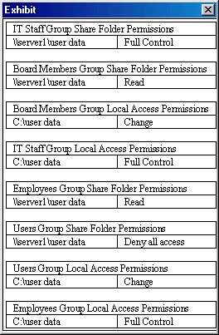

Which users have appropriate access to the folder? (Choose all that apply.)
- Max
- Bob
- John
- Mark
- None of the users will have the appropriate access

- You add a printer to a Windows 2000 Server domain controller. This printer is intended for use only by the top ten executives in the company. They are all members of the Executives group, but there are 75 other executives that are also members of this group. The executives are also members of the Domain Users Group, the Everyone Group, and the Board Members group. The Board Members group contains the 20 board members of the company. You want to configure the printer so only these 10 members can access the printer. How can you perform this function?
- Allow Print permissions to the Executives group and deny access to the printer for all the other groups.
- Allow Full Control permission to the Executives group and deny access to the printer for all the other groups.
- Clear all access to all groups and add the 10 executives to the printer's ACL with Print permissions assigned to each one of them.
- Deny access to all groups and add the 10 executives to the printer's access control list (ACL) with Full Control permissions assigned to each one of them.

- You are the administrator of your Windows 2000 network. The domain controller on the network had a hard drive fail in it. The disk configuration is shown below:

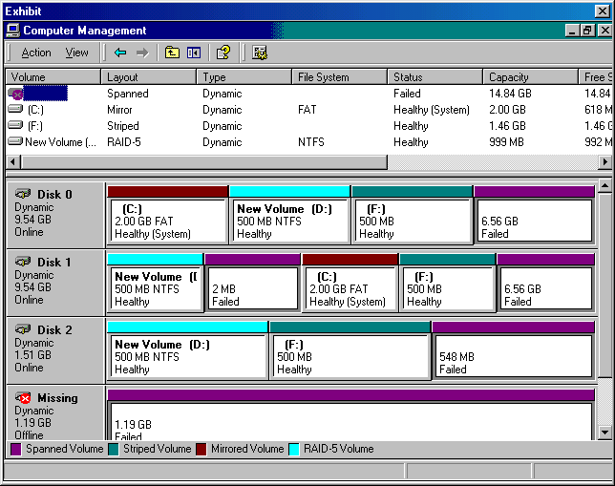

You must meet the following requirements:

You must replace the missing hard drive.
You must recreate all volumes that were affected by the missing hard drive.
You must restore the data to its original state.

You take the following actions:
You replace the hard drive with a 10-GB hard drive.
You make the new hard drive Dynamic.
You recreate the spanned volume allocating 1.19 GB of space for Disk 3 and all the other free space on the other 3 hard drives.
You restore the data from backup.

Which requirements do the actions meet? (Choose all that apply.)
- The missing hard drive is replaced
- The data is restored to its original state
- The actions do not meet any of the requirements
- All volumes affected by the missing hard drive are replaced

- You must implement a 1000-node network. The network will consist of four Windows 2000 domain controllers, two Windows 2000 servers, 3 Hewlett Packard 5SI printers, and 995 Windows 2000 Professional workstations. Your company has been assigned an IP address of 136.18.32.0. You expect the network to double in size to approximately 8 subnets with 250 nodes per subnet in the next two years. How should you configure the IP addressing structure to allow for this configuration so that no single subnet can have more than 300 nodes, but can accommodate at least 250 nodes?
- 136.18.32.0/20
- 136.18.32.0/22
- 136.18.32.0/24
- 136.18.32.0/26

- During the installation of Windows 2000 Server, you receive an insufficient disk space error. There is a small amount of data on this disk that must not be erased, and the server's hardware must not be modified. How can you resolve this error?
- Format the partition
- Install another hard drive
- Verify all hardware is properly detected and on the Hardware Compatibility List
- Create enough free space for the Windows 2000 Server installation on the target partition

- As the network administrator, you must run a processor intensive report every afternoon before closing. You receive many complaints from network users about the network slowing down dramatically during the time this report runs. You must still run the report locally on the Windows 2000 server, but you must minimize the effect on the processor. How can you achieve this functionality?
- Run the application that creates the report with the /BelowNormal switch from the Run line
- Use the Processes tab of Task Manager and set the priority of the process running the report to Low
- Use the Performance tab of Task Manager and set the priority of the process running the report to Low.
- Use the Processes tab of Task Manager and set the priority of the process running the report to Realtime.
- Use the Performance tab of Task Manager and set the priority of the process running the report to Realtime.

- You are the administrator for a Windows 2000 network. The company consists of the corporate office located in Miami, Florida, and branch offices located in Daytona, Florida and Mobile, Alabama. The Miami office recently added a new Windows 2000 Server computer with remote access enabled and 40 Windows 2000 Professional client computers. The Daytona office houses 1 Windows NT 3.51 remote access enabled server computer and 20 Windows 98 client computers. The Mobile office houses 1 Windows NT 3.51 remote access enabled server computer and 10 Windows 98 client computers.

From the Miami office, you attempt a Point-to-Point Protocol (PPP) conversation with the server at the Daytona office. You receive no response. You attempt the same PPP conversation with the server at the Mobile office. Again, you receive no response.

What may be the problem?
- The servers at the Miami and Mobile offices are not configured to use PPP
- The servers at the Daytona and Mobile offices are not configured to use PPP
- The PPP conversations are not configured to access the servers at the Daytona and Miami offices
- The PPP conversations do not support conversations with the operating systems on the servers at the Miami and Mobile offices

- You are configuring your Windows 2000 server and must configure certain information on a fault tolerant volume. You must store the entire Exchange database and all customer information so a single failed disk in the drive will not lose any information. The partitions in the drive are as follows:
C:\- 2-GB FAT RAID Level 1 partition
D:\- 6-GB NTFS RAID Level 5 partition
F:\- 2-GB FAT32 striped set
G:\- 13-GB FAT32 spanned volume

On which partition could you store the information if you needed to encrypt the files?
- C:
- D:
- F:
- G:

- You are the administrator of your company's Windows 2000 domain controller. The domain controller contains three 5-GB hard drives. They are configured as follows:

The system partition is a 2-GB NTFS partition and is assigned the C: drive letter.
There is a RAID 5 volume that is composed of 2 GB from each drive and is assigned the D: drive letter.
There is a 1-GB FAT partition on DISK 0 that is assigned the E: drive letter.
There are two 3-GB FAT32 partitions that fill the remaining space on the other two drives. They are assigned letters F: and G: respectively.

You must optimize the disk space on the drives to meet the following requirements:
You must check all volumes for errors.
You must optimize the speed with which your applications initialize.
You must ensure all files are arranged on the volumes in a contiguous manner.
You must ensure the RAID volume is adequately prepared to minimize install time and initialization time of the program.

You take the following actions:
You use the Check Disk tool on all the drives.
You use Disk Defragmenter to analyze and defragment all volumes.

Which requirements are met by the actions? (Choose all that apply.)
- All volumes are checked for errors
- All files are arranged on each volume in a contiguous manner
- The speed with which your applications initialize is optimized
- The RAID volume is adequately prepared to minimize install time and initialization time of applications

- You have two disks in your Windows 2000 server. You must protect the system partition by creating an exact duplicate of it so if one of the hard drives fails, the system information is still protected. How should you configure the computer's hard disks?
- As a striped set
- As a spanned volume
- As a RAID level 1 configuration
- As a RAID level 5 configuration

- A Windows 2000 server print device fails and can no longer print successfully. You must print a specific document sent to the print device. The queue for the print device has 200 pending print jobs. How can you print the specific document?
- Print the document to a file
- Delete and recreate the print device
- Redirect the single document to another print device
- Redirect all documents to a different print device

- You are the administrator for a Windows 2000 network with Remote Access, Active Directory, and Group Policies configured. The network consists of 10 Windows 2000 Server computers and 500 Windows 2000 Professional client computers.

You have been instructed to completely secure the network. You want to centrally apply the security levels that are required to protect the enterprise systems. What must you access to apply the settings?
- Group Policy snap-in
- Security Configuration and Analysis snap-in
- Active Directory Domains and Trusts snap-in
- Active Directory Sites and Services snap-in

- As the network administrator of your company's network, you must install five new Windows 2000 servers on your network. During the installation of the servers, you must ensure they have the following functionality:

The servers must be able to configure and manage Web sites, NNTP traffic, and FTP traffic.
The servers must provide support so users can easily search for a specified document by using its text or properties.
The servers must provide name resolution for Windows 2000 clients.
The servers must provide services so the UNIX servers on the network can print to the printers attached to the Windows 2000 servers.

You install the following components on each server:
Internet Information Services (IIS)
All Management and Monitoring tools
Microsoft Indexing Services
Microsoft Script Debugger
Remote Installation Services
Remote Storage
Windows Media Services
Networking Services- Dynamic Host Configuration Protocol
Networking Services- Domain Name System
Print Services for UNIX

Which functionality is available given the above optional components on the Windows 2000 servers? (Choose all that apply.)
- The servers provide name resolution for Windows 2000 clients
- The servers can configure and manage Web sites, NNTP traffic, and FTP traffic
- The servers allow for users to easily search for a specified document by using its text or properties
- The servers provide services so the UNIX servers on the network can print to the printers attached to the Windows 2000 servers

- You are a member of your company’s MIS team. The company has three Windows 2000 domain controllers, fifteen member servers, and 1000 Windows 2000 Professional workstations. You have the rights to run Word and Excel on one of the domain controllers. In fact, you are required to update a Word document and an Excel document weekly. You own the Word document so it is stored in the C:\Documents and Settings\Username\My Documents folder. The spreadsheet is stored in the D:\Excel_docs folder and you have Full Access permissions to it, but you do not own it. In order to prepare the Word document, you must access the C:\Custom folder on the domain controller. In order to prepare the Excel spreadsheet, you must have access to the D:\Accounts folder.

You are a member of the Server Operators group, and you have the following permissions to the folders:
You have Full Control access to the C:\Documents and Settings\Username\My Documents folder.
You have Modify permissions to the D:\Excel_docs folder.
You have Read access to the D:\Accounts folder.
You have Read access to the C:\Custom folder.

When you come into work on Monday morning, you notice that the files are corrupt. You created a full backup on Friday before you left for all the folders you had rights to back up. You need to restore all folders and the System State Data if you have the appropriate permissions to do so on the server. Which folders or information can you restore? (Choose all that apply.)
- C:\Custom folder
- System State Data
- D:\Accounts folder
- D:\Excel_docs folder
- C:\Documents and Settings\Username\My Documents folder

- You must update your modem's driver on your Windows 2000 Server computer. You download a signed Windows 2000 driver from the manufacturer's Web site and save it to a floppy disk. How can you upgrade the driver?
- Use the Add/Remove Hardware Wizard
- You must update the driver using the Windows Update Web site
- Use the Driver tab of the modem in Device Manager and select the Update Driver option
- Use the General tab of the modem in Device Manager and select the Troubleshooter option

- Your Windows 2000 server's hard drive configuration follows:

C:\- 2-GB FAT RAID Level 1 partition
D:\- 999-MB NTFS RAID Level 5 partition
E:\- CD-ROM
F:\- 500-MB FAT32 striped set
G:\- 13.66-GB FAT32 spanned volume.

You must store the paging file on the disk configuration with the fastest write access. Which disk should you configure the paging file to use?
- C:
- D:
- E:
- F:
- G:

- You have four partitions in your Windows 2000 computer. They are as follows:

C:\- 2-GB FAT RAID Level 1 partition
D:\- 999-MB NTFS RAID Level 5 partition
E:\- 500-MB FAT32 striped set
F:\- 13.66-GB FAT32 spanned volume.

You must store vital customer information on a disk configuration that provides redundancy in the event a single disk fails in the system, and you must store trade secret information on a volume that can encrypt the folder using the Encrypting File System (EFS). How should you store the information? (Choose all that apply.)
- Store the customer information on drive C:
Store the trade secret information on drive D:
- Store the customer information on drive C:
Store the trade secret information on drive D:
- Store the customer information on drive C:
Store the trade secret information on drive E:
- Store the customer information on drive E:
Store the trade secret information on drive D:

- You are the administrator for your company's Windows 2000 network. Your network is configured as shown below:

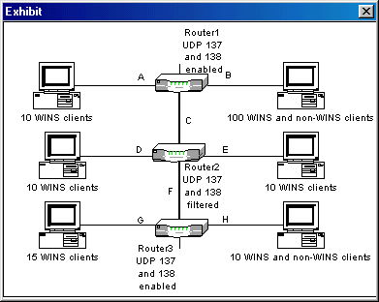

You have been asked to use Windows Internet Name Service (WINS) to provide NetBIOS name resolution for your entire network. You want to complete this task with as little administrative overhead as possible.

You set up a Windows 2000 Server computer on segment A and install the Windows Internet Name Service (WINS) on the computer.

What do you accomplish?
- Only clients on segment A are able to resolve NetBIOS names
- Only clients on segments A and B are able to resolve NetBIOS names
- All clients except the non-WINS clients on segments B and H are able to resolve NetBIOS names
- All clients except the non-WINS clients on segment H are able to use WINS to resolve NetBIOS names

- You installed an updated SCSI driver on your Windows 2000 server and now the computer will not boot. How should you proceed to resolve the problem?
- Boot the computer using Safe Mode
- Boot the computer using Recovery Console
- Boot the computer using the Emergency Repair Disk
- Boot the computer using the Last Known Good Configuration

- You are the administrator for a Windows 2000 network. The network is configured for Active Directory and Group Policies. The network only uses Windows 2000 Server and Windows 2000 Professional computers.

You are currently making configuration changes. You decide to implement auditing to better track activities on the network. You want to implement auditing for the following events:

attempts to change Active Directory objects
attempts to create shortcuts
attempts to access files
attempts to dial in to an Internet Service Provider
attempts to log on to and off computers

Which of these events can be audited by implementing an Audit Policy? (Choose all that apply.)
- Attempts to access files
- Attempts to create shortcuts
- Attempts to log on and off computers
- Attempts to change Active Directory objects
- Attempts to dial in to an Internet Service Provider

- You have recently been hired as the administrator for a Windows 2000 network. The network uses Windows 2000 Server computers.

You want to remove a network adapter from one of the servers and install it into another server. You need to ensure that the server computer, from which you are removing the network adapter, is cleaned of unnecessary files. This means you need to ensure that the device drivers are removed from the server.

What should you access to accomplish this task?
- The System component
- The Add/Remove Hardware component
- The Add/Remove Software component
- The Network and Dial-Up Connections component

- As the Windows 2000 network administrator, you installed Windows 2000 Server on a Pentium III 733 MHz computer with 256 MB of RAM and a 20-GB hard drive. You view the Device Manager and notice that there is a yellow question mark next to the Realtek RTL8139 PCI Fast Ethernet NIC. You must meet the following requirements to properly troubleshoot this problem:

You must install a new driver so the network card will function properly.
You must search for a signed driver before you add an unsigned driver.
You must add an unsigned driver if there is not a suitable signed driver.
You must be warned before installing any unsigned driver into the system.

You propose the following actions to resolve the problem:
You select Driver Signing from the Device Manager of the System Properties utility, and select the Block button.
You right-click on the Realtek RTL8139 PCI Fast Ethernet NIC and select Scan for Hardware changes. (No new hardware was detected.)
You right-click on the Realtek RTL8139 PCI Fast Ethernet NIC, select Properties, select the Driver tab, select Update Driver, and install an unsigned driver from floppy disk.

What do the actions provide? (Choose all that apply.)
- The actions allow a new driver to be installed on the computer
- The actions enable Windows 2000 to search for a suitable driver
- The actions allow you to install an unsigned driver in the event a suitable signed driver is not found
- The actions warn the administrator that they are installing an unsigned driver before installing the driver

- You are the administrator for your company's weconsult.com domain. Your network consists of a main office and two branch offices. The branches are connected to the main office by 256-Kbps leased lines. You have a single Domain Name System (DNS) zone. All DNS servers are located at the main office. All servers are Windows 2000 Server computers. Your network is not connected to the Internet.

Users report that response times are extremely slow when they attempt to access resources on the intranet. When you monitor the network, you discover that DNS name resolution queries are generating heavy traffic across the Wide Area Network (WAN).

You want to accomplish the following goals:

Reduce name resolution traffic across the WAN.
Reduce response times for name resolution queries.
Minimize administrative overhead for DNS maintenance.
Maintain current DNS namespace design.

You take the following actions:

Create a new secondary DNS zone at each branch.
Use the primary zone at the main office as the master zone.
Configure the client computers to query the local DNS servers.

Which goal or goals are accomplished from these actions? (Choose all that apply.)
- Maintain current DNS namespace design
- Reduce name resolution traffic across the WAN
- Reduce response times for name resolution queries
- Minimize administrative overhead for DNS maintenance

- Drive C: on your Windows 2000 server has a compressed folder on it named C:\Server_Files. You must move this folder to Drive D: and encrypt this folder. Drive D: is a 5-GB FAT32 volume and Drive C: is a 3-GB NTFS partition. How can you move the file to the D: volume and encrypt it?
- You move the C:\Server_Files folder to the D: drive, right-click on the folder’s Properties, select Advanced from the General Tab, and select the check box to "Encrypt contents to secure data".
- You convert drive D: to an NTFS partition, move the C:\Server_Files folder to the D: drive, right-click on the folder’s Properties, select Advanced from the General Tab, and select the check box to "Encrypt contents to secure data".
- You move the C:\Server_Files folder to the D: drive, right-click on the folder’s Properties, select Advanced from the General Tab, remove the compression settings from the folder, and select the check box to "Encrypt contents to secure data".
- You convert drive D: to an NTFS partition, move the C:\Server_Files folder to the D: drive, right-click on the folder’s Properties, select Advanced from the General Tab, remove the compression setting from the folder, and select the check box to "Encrypt contents to secure data".

- As the network administrator, you must upgrade 3 Windows NT Workstation 4.0 computers to the Windows 2000 Server operating system. The Windows 98 computers are Pentium III 550 MHz computers with 256 MB of RAM, but they do not have a CD-ROM in them. You must perform an over-the-network install of the operating system. How can you perform this function?
- Boot the computers with an MS-DOS network boot disk
- Upgrade the new operating system using the Winnt.exe command
- Boot the computers with the Windows NT 4.0 Workstation Emergency Repair Disk
- Migrate to the new operating system using the Winnt32.exe command from the Run line of Windows NT 4.0 Workstation

- You have a Pentium III 550 MHz Windows 2000 Server computer with a 10-GB hard disk and 128 MB of RAM. The motherboard on the server has a built-in sound card. The hard drive is partitioned into two 5-GB partitions. You must configure the server as follows:

You must add a second 10-GB hard drive and mirror the primary partition.
You must install a high-end sound card that is on the Hardware Compatibility List (HCL) and enable it on the server.
You must install a modem that is not on the HCL and the unsigned drivers for it.
You must install a Plug-and-Play CD-ROM.

You take the following actions:
While the computer is off, you install the hard drive, the sound card, the modem, and the CD-ROM.
When you boot the computer, you allow the operating system to automatically detect and install the CD-ROM drive and the sound card.
Using the Hardware tab of the System Properties, you select Driver Signing, and select the Warn radio button. Then, you manually install the driver for the modem and ignore the warnings.
Using the Computer Management MMC snap-in, you select Disk Management, you make both disks dynamic disks, and then you create a mirror of Disk 0's first partition.

Which requirements do the actions provide? (Choose all that apply.)
- The CD-ROM is properly installed
- The high-end sound card is properly configured
- The hard drive is added, and the mirror is properly configured
- The modem is properly installed along with the unsigned drivers

- You are the administrator of your Windows 2000 network. The network's domain controller had Disk 1 fail in it. The disk configuration follows:

Disk 0, 1, 2, and 3 each have 2 GB that compose a RAID 5 volume.
Disk 0 and 1 each have 6 GB that compose a RAID 1 volume.
Disk 1, 2, and 3 each have 2 GB that compose a striped set.
Disk 1 and 3 each have 2 GB that compose a spanned volume.

You have not created a backup in three months. Which volumes can you recover without a backup?
- striped set
- RAID 1 volume
- RAID 5 volume
- Spanned volume

- You must configure all Windows 2000 Professional computers to automatically receive an IP address from a Windows 2000 server. How can you configure this functionality on the server? (Choose all that apply.)
- Configure a scope on the server
- Make the Windows 2000 server a DNS server
- Make the Windows 2000 server a DHCP server
- Make the Windows 2000 server a WINS server

- You administer a domain on a Windows 2000 network. The network uses Active Directory and contains a DNS server. The network consists of all Windows 2000 Server computers and Windows 2000 Professional client computers.

You have received many complaints by users that work on several computers throughout the company. They need to be able to access their files and folders while working on a different computer. You have decided to make configuration changes to allow users to reach their files and folders.

What will you implement to accomplish this?
- mandatory profiles
- local user profiles
- additional profiles
- roaming user profiles

- You are the administrator for a Windows 2000 network. The network consists of 2 Windows 2000 Server computers and 30 Windows 2000 Professional client computers.

Your company recently created a new division and hired several new employees. You must create local user accounts because they will not initially be connected to the network. What must you access to create these accounts?
- The DNS snap-in
- The Group Policy snap-in
- The Local Users and Groups snap-in
- The Active Directory Users and Computers snap-in

- You are the administrator of your Windows 2000 network. The network has two Windows 2000 domain controllers, three Windows NT 4.0 domain controllers, 600 Windows 2000 Professional workstations, and 500 Windows NT 4.0 Workstation computers. You must view the allocated resources of the Windows 2000 domain controllers as follows:

You must monitor the system's cache settings.
You must monitor the CPU usage.
You must monitor the memory usage.
You must monitor the amount the CPU is used by the operating system.

You take the following action:
You decide to use Task Manager's Performance Tab and use the View menu to select Show Kernel times.

What does the action provide? (Choose all that apply.)
- The CPU usage will be monitored
- The memory usage will be monitored
- The system’s cache setting will be monitored
- The amount the CPU is used by the operating system will be monitored

- You are the administrator of your Windows 2000 network and you must configure driver signing options for several Windows 2000 domain controllers. Both domain controllers have 100 Windows 2000 Professional clients. You configure the computers as follows:

On the Marketing domain controller, you configure the server's signature verification setting to Block.
On the Accounting domain controller, you configure the server's signature verification to Warn.
You configure each Windows 2000 Professional computer's signature verification setting to Ignore.

Which computers can have an unsigned driver installed on them? (Choose all that apply.)
- Marketing domain controller
- Accounting domain controllers
- Marketing Windows 2000 Professional Clients
- Accounting Windows 2000 professional Clients

- Your Windows 2000 network consists of all Windows 2000 Server computers and Windows 2000 Professional client computers. The network uses a Routing and Remote Access server.

As the administrator for the network, you decide to configure the remote access server to allow a dial-in connection to access more than one line. You decide to accept the default for the Bandwidth Allocation Protocol (BAP) settings. The default setting is to reduce a Multilink connection by one line if the lines fall below 50% capacity for a period of 2 minutes.

While testing Multilink, you determine that the Multilink and BAP settings are not being enforced. What must you do to resolve this problem?
- Enable Multilink and BAP
- Enable the Restrict maximum session to property
- Enable the Extensible Authentication Protocol property
- Enable the Require BAP for dynamic Multilink requests property

- Your Windows 2000 server has a single 6-GB NTFS partition on it. You must enforce disk quota limits on your Windows 2000 server so all users are restricted from storing over 100 MB on the server. However, there is a small group of people in the Sysops group that must store more than 100 MB on the server's hard drive, and you do not want to limit these users to a quota. How can you configure the quota on the hard drive without adding another hard drive to the computer?
- This is not possible
- You must add another hard drive to the computer, format the drive using NTFS, and assign only the Sysops group permission to the drive
- Configure quotas on this hard drive for all the users and limit the quota to 100 MB selecting the check box to not allow users to exceed their quota
- Configure quotas on this hard drive for all the users and limit the quota to 100 MB selecting the check box to not allow users to exceed their quota. In addition, select the Quota entries box on the Quota page and configure the Sysops group so there is no quota limit for members of this group.

- You are a Windows 2000 network administrator. You are planning to implement Terminal Services on the network. While researching the service, you see that a component of Terminal Services is used to maintain data that is necessary to activate license servers and issue client license key packs to the license servers that request them.

Which component were you researching?
- License Server
- Terminal Server
- Client Licenses
- Microsoft Clearinghouse

- You are the administrator for your Windows 2000 network. You have a Windows 2000 Server computer that is your Dynamic Host Configuration Protocol (DHCP) server. Another Windows 2000 Server computer is your Domain Name System (DNS) server.

You want the DHCP server to configure the DNS server setting for all DHCP clients.

What should you do?
- Use DHCP option 6
- Use DHCP option 44
- Use DHCP option 46
- Use DHCP options 44 and 46

- Your company currently has a Windows NT 4.0 domain with a PDC, 3 BDCs, and 10 Member servers. All servers have Intel Pentium III processors in them except for one of the member servers, which has a RISC processor in it. There is also a Windows NT 4.0 domain with a single PDC. The current domains use DHCP and WINS. You are in charge of the operating system migration and the domain migration to Windows 2000. During the migration, you must meet the following requirements:

You must migrate the operating system of all Intel-based Windows NT 4.0 servers to Windows 2000 Server.
You must migrate the operating system of the RISC-based Windows NT 4.0 server to Windows 2000 Server.
You must migrate the domain from a Windows NT 4.0 domain to a Windows 2000 native domain.
You must consolidate the two domains into a single Windows 2000 domain.

You take the following actions:
You upgrade the new operating system using the Winnt32.exe command from the Windows NT 4.0 Run line on all of the Windows NT 4.0 servers. Once Windows 2000 is installed, you run the DCPromo.exe command on the Run line of all the previous PDCs and BDCs.
You ensure all domain controllers use the NTFS file system structure.
You disable the WINS and DHCP services on all the Windows NT 4.0 domain controllers that the service runs on.
Once the operating system migration occurs, you ensure the DHCP and WINS services are running.
You consolidate the domain by moving the PDC on the domain with a single server into the newly created Windows 2000 domain's OU.
Once all servers are upgraded to Windows 2000, you set the domain mode as native on one of the domain controllers.

Which requirements do the above actions meet? (Choose all that apply.)
- The domain structure is consolidated into a single domain
- The domain is successfully migrated to a Windows 2000 native domain
- The migration of the operating system of the RISC-based Windows NT 4.0 server to Windows 2000 Server is successfully accomplished
- The migration of the operating system of all Intel-based Windows NT 4.0 servers to Windows 2000 Server is successfully accomplished

- Your company has recently decided to implement a new Windows 2000 network. You were promoted to be a member of a team of administrators for the network.

Your team is making decisions about certain aspects of the network. Currently, your team is discussing user account naming conventions.

What are valid considerations for deciding on these standards? (Choose all that apply.)
- User logon names in Windows 2000 are case sensitive
- Windows 2000 only recognizes 20 characters in a logon name
- The company may have employees with the same or similar names
- The company may hire temporary employees that may need to be identified with a user account

- Your network has a Windows 2000 Active Directory server, three file and print servers, and a NetWare 4.1 server. In addition, there are 200 Windows 98 client computers and 1000 Windows 2000 Professional client computers. You multihomed your Windows 2000 Active Directory server and you must configure the first network adapter so it can only communicate with the NetWare server (you do not want this network adapter to connect to any Windows client computers). You must configure the second network adapter so it can only communicate with the Windows server and client computers on the network. All Windows server and client computers on the network use the TCP/IP protocol. How must you configure the network adapter on the LAN connection so the first network adapter can only communicate with the NetWare server?
- Install the NWLink protocol
- Install Internet Protocol (TCP/IP)
- Install Client for Microsoft Networks
- Install Gateway Services for NetWare
- Install File and Print Sharing for Microsoft Networks

- As the network administrator of your Windows 2000 network, you are in charge of configuring all the required services that run on the Windows 2000 domain controllers. The network has three Windows 2000 domain controllers, two Windows NT 4.0 member servers, 500 Windows 98 clients, 1600 Windows NT 4.0 Workstation computers, and 500 Windows 2000 Professional computers. You must meet the following requirements:

You must monitor remote traffic from the Windows 2000 domain controllers.
You must implement Active Directory into your environment.
All clients must receive an IP address automatically.
You must configure functionality so the Windows 98 computers on the subnet can resolve NetBIOS names to IP addresses.

You take the following actions:

You add a DHCP server to each subnet and configure the clients to automatically assign an IP address. In addition, you add a WINS server to each subnet and configure all clients to be DHCP clients and all Windows 98 clients to be WINS clients.
You configure all Windows 2000 domain environments to operate in mixed-mode.
You configure the domain controller with SMS 2.0 and use its version of Network Monitor to monitor the domain controller network traffic.
On one of the domain controllers that is a DHCP server, you type dcpromo.exe at the Run line.

Which requirements do the actions meet? (Choose all that apply.)
- All clients must receive an IP address automatically
- You must implement Active Directory into your environment
- You must monitor remote traffic from the Windows 2000 domain controllers
- You must configure functionality so the Windows 98 computers on the subnet can resolve NetBIOS names to IP addresses

- You have a Windows 2000 Server and 50 Windows 2000 Professional computers on your Windows 2000 network. You must configure the client computers so they can be moved to another subnet without any modifications. How can you configure the client computers?
- Configure the clients as DNS clients
- Configure the clients as DHCP servers
- Configure the clients as WINS clients
- Configure the clients as DHCP clients

- You must manage the way your Windows 2000 domain controller manages processes. The Windows 2000 domain controller has two Pentium III processors in it. The domain controller serves six Windows 2000 Professional computers. You must customize several processes on the domain controller as follows:

You must assign the Exchange process exclusively to one of the processors.
You must run Access in High priority mode.
You must run Outlook in real-time.
You must run an old custom application in the slowest possible process setting.

You take the following actions using Task Manager:
You right-click on the Exchange process, select Set Affinity, and select the appropriate processor.
You right-click the Access process, select Set priority, and select High.
You right-click the Outlook process, select Set priority, and select Realtime.
You right-click the custom program’s process, select Set priority, and select Low.

Which process or processes are properly configured? (Choose all that apply.)
- Access
- Outlook
- Exchange
- Custom Program

- You have been hired by a Fortune 500 company to implement security into their Windows 2000 domain. The network at the corporate office has 10 Windows 2000 servers, 50 Windows NT 4.0 Servers, 2000 Windows 2000 Professional workstations, 600 Windows NT 4.0 workstations, and 2500 Windows 98 computers. You must configure auditing on one of the Windows 2000 servers to meet the following requirements:

You must audit the failed attempts when a domain controller receives a request to validate a user account.
You must audit the successful attempts when an administrator changes a group within the domain.
You must audit failed attempts to change user rights.
You must audit failed attempts to shut down the server.

You set the audit policy as shown below:

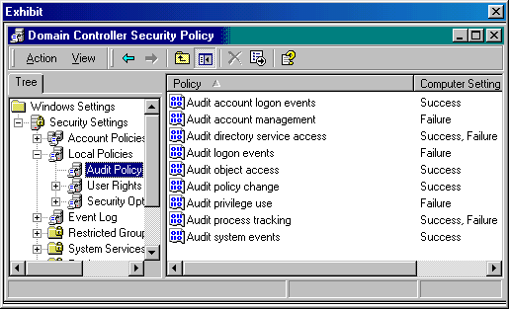

Which requirements does the audit policy meet?
- Attempts will be audited when a change to user rights fails
- None of the events will be audited with the current audit policy
- Attempts will be audited when a user attempts to shut down the server and fails
- Successful attempts will be audited when an administrator changes a group within the domain
- Failed attempts will be audited when a domain controller receives a request to validate a user account

- Your company uses a Windows 2000 network of which you are the administrator. Users on the network use the Microsoft Office 2000 programs in their work.

You receive a call from a user running Access 2000. The user informs you that she received an error while working in the program. You want to know the details of the error, but the user already cleared the error from the screen.

How can you view the details of the error from the Event Viewer?
- View the System log
- View the Security log
- View the Application log
- View the Directory Service log

- How can you view the percentage the CPU is used by the operating system on a Windows 2000 server?
- Use the Windows 2000 Performance Monitor to view the desired setting
- Use Task Manager’s Process Tab, select the View menu, and select Show Kernel times
- Use Task Manager’s Performance Tab, select the View menu, and select Show Kernel times
- Use Task Manager’s Applications Tab, select the View menu, and select Show Kernel times

- You must implement a 10,000-node network. The network will consist of forty Windows 2000 domain controllers, twenty Windows 2000 servers, 60 Hewlett Packard 5SI printers, and 9000 Windows 2000 Professional workstations. Your company has been assigned an IP address of 136.18.32.0. You expect the network to double in size to approximately 10 subnets with 2000 nodes per subnet in the next two years. How should you configure the IP addressing structure to allow for this configuration?
- 136.18.32.0/20
- 136.18.32.0/22
- 136.18.32.0/24
- 136.18.32.0/26

- You are one of the administrators for a Windows 2000 network. The network consists of Windows 2000 Server and Windows 2000 Professional computers, and includes a DNS server. Active Directory and Group Policies are configured on the network.

You have recently been given the task of evaluating ways to protect your user data files on the network. You are considering the Encrypting File System (EFS).

What are characteristics you should consider when making this decision? (Choose all that apply.)
- Compressed files cannot be encrypted
- Encrypted files cannot be shared among users
- Encrypted files and folders cannot be deleted
- Only files and folders on NTFS volumes can be encrypted
- You cannot encrypt files and folders on a remote computer
- Using cutting and pasting to move files into an encrypted folder will not encrypt the files

- You have an OptraX printer manufactured by Lexmark. The printer is connected to a Windows 2000 server and the server shares the printer on the network. The network has 500 Windows 95 client computers. When the Windows 95 computers attempt to print to the printer, they receive a message that there is no driver installed for the printer. How should you resolve this problem with the least amount of effort?
- Reinstall the printer on the server
- Install the Windows 95 printer driver on the server
- Install the Windows 95 printer driver on the client computers
- Install the Windows 95 printer driver on the client computers and on the server

- You must add a 7-GB program to a 25-GB RAID Level 5 Volume. The RAID 5 volume is about 4 months old, and the existing network uses a 100BaseT network. You must prepare the volume to minimize install and initialization time of the program. How can you prepare the RAID level 5 configuration to optimize the installation and initialization time of the program?
- Defragment the volume
- Scan the volume for errors
- Change the volume to a RAID level 1
- Upgrade the network to an FDDI network

- You must connect a satellite office to the main office network using the least expensive method. At the main office, you will connect to a Windows 2000 server using a Windows 2000 Professional computer from the satellite office. How should you make the connection using the most secure method over a frame relay PVC connection?
- Implement a VPN connection with the IP in IP (IP-IP) protocol
- Implement a VPN connection with the Point-to-Point Tunneling Protocol (PPTP)
- Implement a VPN connection with the Layer Two Tunneling Protocol (L2TP)
- Implement a VPN connection with the PPTP protocol using IPSec Encapsulating Security Payload (ESP) Tunnel Mode

- You are a member of a team of network administrators for a Windows 2000 network. The network uses Windows 2000 Server and Windows 2000 Professional computers.

You are attempting to make configuration changes that will aid the administrators in managing security settings for the local computer policies. One of the changes you would like to implement is for users to be automatically logged off the network after a specified amount of time.

How can you implement this change?
- From the Group Policy snap-in, enable the "Shut down the system" option in User Rights Assignment.
- From the Group Policy snap-in, enable the "Force shutdown from a remote system" option in User Rights Assignment.
- From the Group Policy snap-in, enable the "Amount of idle time required before disconnecting system" option in Security Options.
- From the Group Policy snap-in, enable the "Automatically log off users when logon time expires (local)" option in Security Options.

- As the network administrator of your Windows 2000 network, you must add four Novell NetWare 5.1 servers to your network. Your current network has 4 Windows 2000 Advanced Server domain controllers using the Cluster service, 10 Windows 2000 Server domain controllers, and 6000 Windows 2000 Professional client computers. In addition, there are 1500 laptops throughout the corporation. There are cluster servers located in New York, Atlanta, Los Angeles, and Miami. Each of these locations contains at least two Windows 2000 servers and 1500 client computers. All of the sites are connected via a T1 connection to form the WAN. All four local area networks are ATM frame relay networks. TCP/IP is the only protocol on the network. You must add the NetWare servers to achieve the following functionality:

The four NetWare servers must integrate into the existing network and you must place one at each location.
You must allow all clients to access the NetWare servers' shared resources.
You must configure the Windows 2000 servers so the laptop users can dial in to the network.
You must configure the network so the TCP/IP protocol is the only protocol installed on the network.

You take the following actions:
You configure Gateway Services for NetWare (GSNW) on each of the Windows 2000 cluster servers.
You install the NetWare 5.1 server software using its native protocol.
You install Routing and Remote Access, configure it accordingly on the servers, and configure the clients to dial in.

Which requirements do the actions meet? (Choose all that apply.)
- All clients can access the NetWare servers’ shared resources
- The TCP/IP protocol is the only protocol used on the network
- The laptop users can dial in to the network via the Windows 2000 servers
- The four NetWare servers are integrated into the existing network with one at each location

- You are administering a Windows 2000 network with Active Directory and Group Policies configured. The network also consists of DNS and DHCP servers. Auditing is enabled on the network.

You need to be able to determine the resource use on the network, as well as plan for growth on the network. You decide to track trends on the network. How can you accomplish this task?
- By controlling the size of the event logs
- By enabling the inheritance of auditing features
- By setting a schedule for viewing the event logs
- By archiving event logs and comparing logs from different periods

- Your Windows 2000 domain controller has just crashed. As the network administrator, you must restore or execute the following on the server:

Master Boot record
Boot Sector
Format an NTFS partition
Start selected services
Stop selected services.

You take the following actions:
You boot using the setup floppy disks.
You run Windows 2000 setup and press enter at the Setup Notification screen.
You press R to repair the Windows 2000 installation.
You press C.
You press the number key representing the Windows 2000 installation you need to repair.
You enter the administrator password and press enter.

Which requirements do the actions meet? (Choose all that apply.)
- Stop selected services
- Restore the Boot Sector
- Start selected services
- Format an NTFS partition
- Restore the Master Boot record

- You have just upgraded your company's servers from Windows NT 4.0 to Windows 2000. The Windows 2000 domain runs in native mode. The network is composed of a single Windows 2000 domain controller and ten Windows 2000 Professional computers. The domain uses the NetBEUI protocol. Shortly after the upgrade, your company was purchased by a much larger company. The larger company moved its accounting department and the sales department into your facility. You are tasked with the challenge of incorporating new hardware into the network as follows:

Ten Windows NT 4.0 backup domain controllers and 400 Windows 2000 Workstation clients must integrate into the existing network.
Two NetWare servers must integrate into the existing network.
You must allow all clients to access the NetWare servers' shared resources.
You must allow all Windows 2000 clients to authenticate through the Windows 2000 servers.

You take the following actions:
Change the domain mode from native to mixed mode by reinstalling Windows 2000 Server on the existing domain controller and accepting the default domain type.
Remove the NetBEUI protocol from all existing computers and replace it with TCP/IP.
Ensure TCP/IP, Client for Microsoft Networks, and File and Print Sharing for Microsoft Networks are installed on all the clients and servers.
Configure Gateway Services for NetWare (GSNW) on one of the Windows 2000 servers.

Which requirements do the actions meet? (Choose all that apply.)
- The two NetWare servers will integrate into the network
- All clients can access the NetWare server’s shared resources
- The ten NT 4.0 servers will integrate into the network
- All Windows 2000 clients authenticate through the Windows 2000 servers

- You are the administrator of your company's network. The network has a Windows 2000 domain controller and 2 Windows NT 4.0 member servers. The Windows 2000 servers are running in mixed mode. All hard drives in the servers are partitioned with the NTFS partition. Jim is a member of the IT Staff group, the Managers group, and the Users group. See below to view group permissions. He is unable to access the \\w2kserver\test folder from his workstation. How can you resolve this problem? (Choose two ways to resolve this problem.)

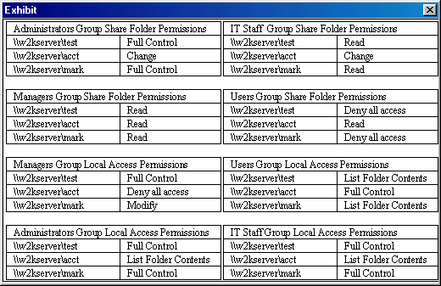
- Remove Jim from the Users group
- Remove Jim from the IT Staff group
- Remove Jim from the Managers group
- Assign the Users group Read access to the share
- Assign the IT Staff group Change access to the share
- Assign the Managers group Full Control access to the share

- You are currently working on a Windows 2000 Server computer on the network you administer. You need to change a configuration setting on the computer. You must make this setting as the user Administrator.

What can you do to prepare for the change?
- From a command prompt, type: user = administrator
- From a command prompt, type: mmc /user administrator
- From a command prompt, type: change user to administrator
- From a command prompt, type: runas /user: administrator mmc

- You are the network administrator of a small Windows 2000 network. The network has a single domain controller and 13 Windows 2000 Professional computers. You are implementing Proxy Server 2.0 into your network and you must configure two network cards on the domain controller. The domain controller has a D-Link and a Realtek network adapter in it. See the screen shots below:

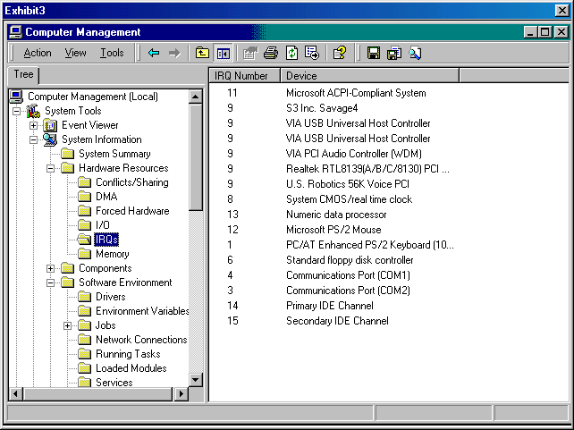
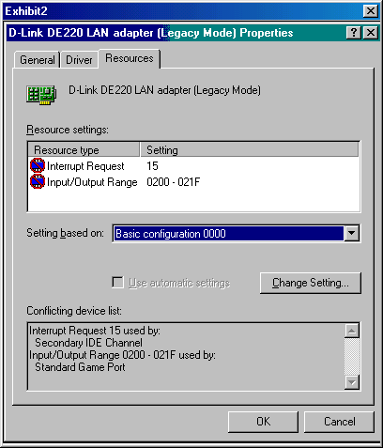
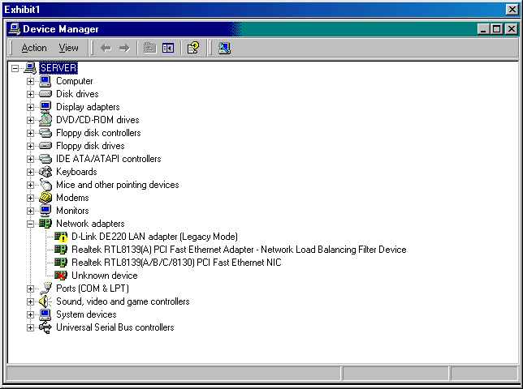

You must meet the following requirements:

You must troubleshoot the D-link network card and configure it so it will work.
You must uninstall the unknown device.
You must force Windows 2000 to scan for hardware changes on the entire computer.
In the event you cannot configure the device properly, you must prevent Windows 2000 from detecting it at startup.

You take the following actions:
You change the IRQ on the D-Link network card to 10 and change the I/O to a free space with no conflicts.
You right-click on the unknown device and select uninstall.
You right-click on SERVER in Device Manager and select "Scan for hardware changes."

Which requirements are met by the actions? (Choose all that apply.)
- The unknown device is installed
- Windows 2000 scanned for hardware changes on the entire computer
- The D-link network card is configured so it will function properly
- If the D-link card could not be properly configured due to system limitations, you must prevent Windows 2000 from detecting it at startup

- You are administering a new Windows 2000 network. The network consists of all Windows 2000 Server computers and Windows 2000 Professional client computers. The network will be configured with Active Directory.

You need to implement local user accounts on all client computers. You want to ensure that you are well prepared for configuring the accounts. You research all information about user accounts.

What is a characteristic of these accounts?
- The server’s security database is used to authenticate the account
- Local user account information is replicated to all domain controllers
- Local user account information is not replicated to the domain controllers
- The local account is created in its original computer’s and server’s security databases

- You administer a Windows 2000 network that consists of Windows 2000 Server and Professional computers. The network is configured to use Active Directory and Group Policies.

You are implementing auditing to track events on the network. You want to track access to Active Directory objects. How can you accomplish this task?
- Enable the Audit object access policy
- Enable the Audit process tracking policy
- Enable the Audit account management policy
- Enable the Audit directory services access policy

- You have a Pentium III 550 MHz Windows 2000 Server computer with a 10-GB hard disk and 128 MB of RAM. There has never been a modem installed on this computer, and you must install a modem that is not on the Hardware Compatibility List (HCL).

How can you install the modem on the Windows 2000 computer? (Choose all that apply.)
- Change the driver signing option to Warn
- Change the driver signing option to Block
- Change the driver signing option to Ignore
- Install the driver from the Driver tab of the Modem’s Properties page in Device Manager
- Use the Add/Remove Hardware Wizard and manually select the device type and location of the driver

- As a newly employed Windows 2000 network administrator at a small company, you have inherited a Windows 2000 domain controller that has a disastrous file system structure. The 3 10-GB hard drives in the domain controller are all formatted differently. The first is a single 10-GB NTFS partition (Drive C:); the second is a single 10-GB FAT32 partition (Drive D); and the third is a combination of a 2-GB FAT partition (Drive E:), a 5-GB FAT32 partition (Drive F:), and a 2-GB NTFS partition (Drive G:). You must modify the configuration as follows:

Drive C: has a compressed folder on it named C:\Accounting. You must move this folder to Drive D: and encrypt it.
Drive D: has a 600-MB folder named Archive full of rarely used documents. You must move this folder to drive G: and compress it.
Drive F: has a very important folder named F:\Salaries. You must encrypt this file.
Drive E: consists of a single folder of customer order history and customer information named Customer Information. You must encrypt this information.

You take the following actions:

You convert drive D:, Drive E:, and Drive F: to NTFS partitions.

You move the C:\Accounting folder to the D: drive, right-click on the folder’s Properties, select Advanced from the General Tab, and select the check box to "Encrypt contents to secure data".

You move the D:\Archive folder to the G: drive, right-click on the folder’s Properties, select Advanced from the General Tab, and select the check box to " Compress contents to save disk space".

You right-click on the F:\Salaries folder, select Properties, select Advanced from the General Tab, and select the check box to "Encrypt contents to secure data".

You right-click on the E:\Customer Information folder, select Properties, select Advanced from the General Tab, and select the check box to "Encrypt contents to secure data".

Which folders are properly configured by the actions? (Choose all that apply.)
- Archive
- Salaries
- Accounting
- Customer Information

- You are the network administrator of a Windows 2000 network that contains 25 domain controllers, 50 member servers, and 6000 workstations. All the computers on the network use Windows 2000 Advanced Server, Windows 2000 Sever, and Windows 2000 Professional operating systems respectively. The Windows 2000 Advanced Server computers are running the Cluster Service. Your company allows you to work at home one day a week and you must travel a lot. Your network uses TCP/IP as its only protocol. You must be able to remotely administer each Windows 2000 server on your network with the following considerations in mind:

You must be able to establish a Virtual Private Network (VPN) connection to the Windows 2000 Server computers so all data encrypts and encapsulates entire datagrams for secure transfer when you work at home.
When you travel, you must be able to perform any task on the main Windows 2000 domain controller while using a remote access connection from a laptop computer.
When you travel, you must be able to edit the registry of the Windows 2000 server while using a remote access connection from a laptop computer.
During the migration process to Windows 2000, you depleted all your financial resources for licensing; therefore, you must not be required to add additional licenses to your network.

You take the following actions:
You implement a VPN connection on the proper server, the laptop, and the home computer so the VPN uses the IPSec protocol in Encapsulating Security Payload (ESP) Tunnel Mode.
You implement Windows 2000 Terminal Services using the Remote Administration mode on the Windows 2000 servers.
You install and configure Routing and Remote Access properly.

What do the actions provide? (Choose all that apply.)
- No additional licenses are required for your network
- The ability to edit the registry of the Windows 2000 server while using a remote access connection from your laptop computer
- The ability to connect to the Internet and establish a VPN connection to the Windows 2000 server computers from your home computer
- The ability to perform any task on the main Windows 2000 domain controller while using a remote access connection from your laptop computer

- You need to initialize Microsoft Excel from Task Manager. How can you perform this function? (Choose all that apply.)
- Use the Applications tab of Task Manager, select the New Task button, and type Excel on the command line.
- Use the Processes tab of Task Manager, select File from the Main Menu, select New Task, and type Excel on the command line.
- Use the Performance tab of Task Manager, select File from the Main Menu, select New Task, and type Excel on the command line.
- Use the Applications tab of Task Manager, select File from the Main Menu, select New Task, and type Excel on the command line.

- Your company has a primary Domain Name System (DNS) server, DNS1.weconsult.com, that is heavily used. CPU utilization is consistently high. Numerous records are stored on DNS1.

You suspect that some DNS queries are resulting in answers that exceed the limit for a single User Datagram Protocol (UDP) packet. You need to investigate to ensure your suspicion is true.

What should you do?
- Start System Monitor. On DNS1, monitor the DNS:UDPMessageMemory counter.
- Start System Monitor. On DNS1, monitor counters DNS:TCPResponsesSent and DNS:TCPResponsesSent/Sec.
- Use Network Monitor to analyze network traffic. Use nslookup on a separate computer to query for NS records on DNS1. Compare the number of UDP packets returned to DNS in response to your queries with the number you issued.
- Use Network Monitor to analyze network traffic. From a client machine, ping host records that are stored on DNS1. Compare the number of UDP packets returned from DNS1 in response to your queries with the number of queries issued.

- You are the administrator for a Windows 2000 network. The network consists of Windows 2000 Server computers and Windows 2000 Professional client computers. The salespeople in the company use portable computers.

Because of complaints from salespeople about connection problems, you have decided to install a hardware device that can be connected to or disconnected from the computer as the user needs it.

Which device can you install to accomplish this task?
- RAM
- PC cards
- TouchPad
- Network adapters

- You are the administrator for a Windows 2000 domain with Remote Access enabled. You want to implement a Virtual Private Network (VPN) so clients can connect to your network through the Internet.

You select a Windows 2000 Server computer to act as your VPN server. You configure the server to use the Layer Two Tunneling Protocol (L2TP) and the Point-to-Point Tunneling Protocol (PPTP).

What is a reason for implementing these protocols?
- You want protocols that will replace the VPN
- You want protocols that use Microsoft Point-to-Point Encryption
- You want protocols that are challenge-response authentication protocols
- You want protocols that will encapsulate Point-to-Point Protocol frames

- You must allow all Windows NT 4.0 Workstation and Server computers to resolve NetBIOS names to IP addresses from a Windows 2000 server. How can you configure this functionality on the server?
- Configure a scope on the server
- Make the Windows 2000 server a DNS server
- Make the Windows 2000 server a DHCP server
- Make the Windows 2000 server a WINS server

- You are trying to configure two network cards in your Windows 2000 server. The server had a legacy 10-Mbps 3Com network interface card (NIC) in it, and you added a 10/100 3Com adapter to the server. You notice the newly installed NIC is causing an IRQ conflict and that both devices are trying to use IRQ 10. The computer does not currently have a sound card in it. How can you resolve this problem?
- Specify IRQ 5 as the IRQ for the original network card
- Reserve IRQ 10 for the new network card in the BIOS setup
- Reserve IRQ 10 for the original network card in Device Manager
- This cannot be done. Windows 2000 Server will not support more than one NIC

- You suspect that an application has hung on your Windows 2000 server. How can you verify your suspicion and close the hung application?
- Use the Processes tab of Task Manager, verify the status of the application, and close the application if the status says Running using the End Task button.
- Use the Applications tab of Task Manager, verify the status of the application, and close the application if the status says Running using the End Task button.
- Use the Processes tab of Task Manager, verify the status of the application, and close the application if the status says Not Responding using the End Task button.
- Use the Applications tab of Task Manager, verify the status of the application, and close the application if the status says Not Responding using the End Task button.

- As the Windows 2000 network administrator, you must configure several shares on your Windows 2000 domain controller so users can access them locally. There are several folders on the server that should only be accessible by the network administrator. See below for file access configuration.

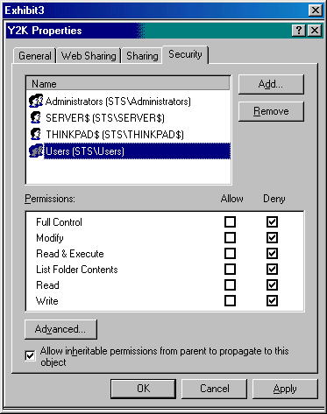
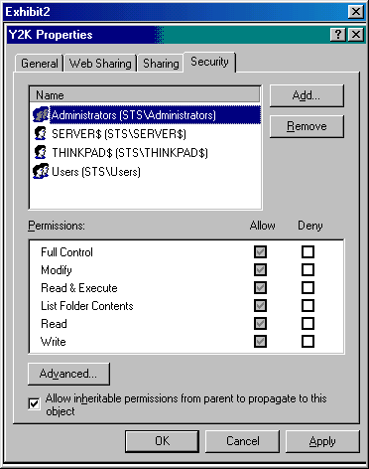
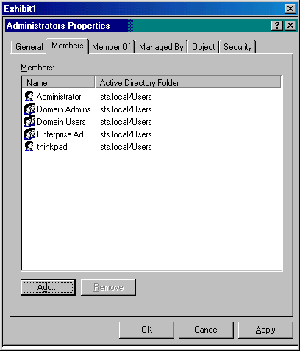

You must configure the domain controller as follows:

You must allow members of the Accounting group local access to the domain controller’s C:\Financial folder.
You must secure the C:\Security_Config folder so only the administrator can access it.
You must configure the C:\Y2K folder so the administrator can access the files locally
You must allow all users remote access to the D:\Benefits folder.

You take the following actions:
You assign the Accounting group Read permission to the C:\Financial folder and assign the group the right to log on locally to the domain controller.
You deny access to all users and groups except the Administrator account.
You deny access to all users and groups except the Administrator account to the C:\Security_Config folder.
You assign Read access to the Everyone group for the D:\Benefits folder.

Which requirements are met by the actions? (Choose all that apply.)
- All remote users can access the D:\Benefits folder
- The C:\Y2K folder can be accessed by the administrator locally
- The C:\Security_Config folder can only be accessed by the administrator
- Members of the Accounting group have local access to the domain controller’s C:\Financial folder

- Your law firm uses the DOS version of Word Perfect and another DOS application to keep track of billing hours. You must monitor the performance of these DOS applications on a Windows 2000 Server computer. You decide to use Performance Monitor. Using Performance Monitor, which counter(s) should you monitor?
- % User Time
- Handle Count
- The single NTVDM that both applications run in
- The Windows Virtual DOS Machines for each application

- You are observing another network administrator for a Windows 2000 network perform maintenance. The administrator is performing maintenance on a network adapter using Device Manager.

Which tasks can he accomplish? (Choose all that apply.)
- Install devices
- Uninstall devices
- Determine whether the device is working properly
- Identify device conflicts and automatically configure resource settings

- You have recently been hired by your company as the administrator for a Windows 2000 network. The network consists of 6 Windows 2000 Server computers, 50 Windows 2000 Professional client computers, and 15 Windows 98 client computers. The network is also configured with DNS, DHCP, Active Directory, and Group Policies.

One of your first assignments as administrator is to implement and administer auditing on the network. After research, what did you determine to be the steps in accomplishing this task? (Choose two.)
- Enable the audit policy
- Enable auditing of specific resources
- Install the auditing service on each computer
- Install auditing on each computer from the domain controller

- You are administering an Active Directory-enabled Windows 2000 network. The network consists of 4 Windows 2000 Server computers and 60 Windows 2000 Professional client computers. There is a total of 15 network printers, and four of those printers are in your company's CEO's office area. These printers print highly sensitive documents and should not be used by other employees.

You have decided to implement auditing to track access to these printers. What is the initial step in accomplishing this task?
- Enable the Audit Logon Events policy
- Enable the Audit Privilege Use policy
- Enable the Audit System Events policy
- Enable the Audit Object Access policy

- You are implementing auditing in your Windows 2000 network. You want to accomplish the following goals:

Implement auditing for network printers.
Track failed attempts to print.
Track failed attempts to manage documents.
Track failed attempts to read permissions.
Track failed attempts to change permissions.
Track failed attempts to take ownership.

You perform the following actions:

Enable the Audit Object Access policy.
Open the Properties dialog box for a specific printer.
Select the Security tab and click the Advanced button.
Select the Auditing tab.
In the Access area, click the Manage Documents box in the Failed column.
Close the Properties dialog box.

Which goal or goals are accomplished by these actions? (Choose all that apply.)
- Track failed attempts to print
- Implement auditing for network printers
- Track failed attempts to take ownership
- Track failed attempts to read permissions
- Track failed attempts to manage documents
- Track failed attempts to change permissions

- You are administering a Windows 2000 network that consists of several new employees. You set up the new local user accounts on each computer.

The user profiles for these accounts will store the current desktop environment and application settings for the user. When will the profiles be created?
- When the computer restarts
- When the account is created
- When the account is enabled
- When the user initially logs on at the computer

- You are administering your Windows 2000 network. The network consists of 4 Windows 2000 Server computers and 55 Windows 2000 Professional client computers. The network uses a DHCP server and Terminal Services.

You need to manage your Remote Desktop Protocol (RDP) configurations. Which Terminal Services tool should you use?
- Terminal Services Manager
- Terminal Services Licensing
- Terminal Services Configuration
- Terminal Services Client Creator

- You must configure Remote Administration on your Windows 2000 laptop so you can establish a Virtual Private Network (VPN) connection to a Windows 2000 server. While transmitting data on the connection, you must encrypt and encapsulate entire datagrams for secure transfer. How should you configure the VPN connection on the laptop?
- Use IP in IP (IP-IP) tunneling
- Use the Layer 2 Tunneling Protocol
- Use the Point-to-Point Tunneling Protocol
- Use the IPSec Encapsulating Security Payload Tunnel Mode protocol

- You are upgrading your company's peer-to-peer Windows 98 network to a Windows 2000 network. You must take a Windows 98 Pentium III 550 MHz computer and make it a Windows 2000 domain controller. The hardware in the computer has a network card and video card that is on the Windows 2000 Hardware Compatibility List (HCL). However, the sound card and modem are not on the Windows 2000 HCL.

You must configure the server so it will not allow unsigned drivers.
You must update the current hardware so it will function with Windows 2000.
You must install new hardware if a signed driver cannot be located for a particular piece of hardware.
You must force Windows 2000 to search for hardware changes when new hardware is installed.

You take the following actions:
You format the hard drive and install Windows 2000 server from the bootable CD-ROM.
You allow the system to boot and log on as the administrator.
You select Driver Signing from the Device Manager of the System Properties utility, and select the Block radio button.
You shut down the computer.
You remove the existing sound card and modem.
You install the new, Windows 2000-compliant sound card and modem into the computer.
You boot the domain controller.
You right-click on the server’s name in Device Manager and select "Scan for hardware changes."

Which requirements do the actions meet? (Choose all that apply.)
- The domain controller will not allow unsigned drivers
- The hardware is updated to Windows 2000-compliant hardware
- All hardware that does not have a signed driver is updated
- Windows 2000 is forced to search for new hardware after the hardware is installed

- You are the administrator of your Windows 2000 network. There are three domain controllers, two member servers, 100 Windows 2000 Professional computers, and six Hewlett Packard 8000 printers on the network. You also have a small testing network you use to test new hardware and software before you integrate them into the production network. You must meet the following requirements:

You must configure your Windows 2000 network servers so no unsigned driver can be installed on them.
You must configure your Windows 2000 Professional computers so drivers tested on the testing network can be installed only if they perform properly on the test network.
You must configure your Windows 2000 servers on the test network so you can install a driver after a warning prompt.
You must configure your Windows 2000 Professional computers on the test network so you can install an unsigned driver without any warning or prompt.

You take the following actions:
On the production network, you configure the servers to Block signature verification, and the Windows 2000 Professional computers to Warn.
On the test network, you configure the servers to Warn for signature verification, and the Windows 2000 Professional computers to Ignore signature verification.

Which computers are properly configured on the network? (Choose all that apply.)
- Test network servers
- Test network workstations
- Production network servers
- Production network workstations

- You are a Windows 2000 domain administrator. There are three Windows 2000 domain controllers, two Windows NT 4.0 Server computers, two Windows 2000 file servers, and 750 Windows 2000 Professional computers. The network is a Frame Relay network. You must configure the network as follows:

You must be able to simplify administration by allowing an administrator to move links to a working domain controller if one of the domain controllers fails on the network.
You must allow users to access files using a single namespace instead of requiring them to map logical drives for the share.
Your solution must preserve network permissions so all shares and security configurations do not need any modifications.
You must replace the outdated file servers since you must retire the old hardware and replace it with faster hardware.

You take the following actions:
You implement Distributed File System (DFS) on your network configuration and you modify it as follows:
You place a new server on the network to replace the outdated server and update the path to the new server in the DFS structure.
You configure Internet Information Services (IIS) 5.0 on the Windows 2000 domain controllers.

Which requirements are met by the actions? (Choose all that apply.)
- You can seamlessly replace file servers
- No additional memory is used by the actions
- Users can access files using a single namespace instead of mapping logical drives for the share
- The administrator can move links to a working domain controller if one of the domain controllers fails on the network

- Your company has just purchased a Hewlett-Packard 6000 printer for the entire Accounting department to use. There are 10 Windows NT 4.0 client computers, 10 Windows 3.11 client computers, 20 Windows 2000 client computers, 1 UNIX server, and 65 Windows 98 laptop users. You add the printer to the only Windows 2000 server in the department and must configure it for use by every computer in the department. After installing and sharing the printer, you decide to use the Add Printer Wizard on the Windows 2000, Windows 98, and Windows NT 4.0 client computers. Which computers can print to the HP 6000 printer? (Choose all that apply.)
- UNIX
- Windows 98
- Windows 3.11
- Windows 2000
- Windows NT 4.0

- You implemented a Windows 2000 server into your Windows 2000 network three months ago. The server has a 6-GB FAT32 partition and is part of a 10BaseT network. Users report that they had great response times when the server was first installed, but the response times have significantly and steadily decreased over the past several months. How can you resolve this problem?
- Defragment the partition
- Scan the disk for errors
- Convert the partition to NTFS
- Upgrade the network to a 100BaseT network

- During the installation of Windows 2000 Server via a CD-ROM disk, you receive an unsupported CD-ROM drive error. How can you resolve this error?
- Verify all hardware is properly detected and on the HCL
- Contact Microsoft and request a Windows 2000 server replacement CD
- Ensure the target partition has sufficient free space for the Windows 2000 server installation
- Replace the CD-ROM drive with one that is on the Windows 2000 Hardware Compatibility List

- You must prevent users from deploying service packs on their systems using the Microsoft Web site. Your network has a single Active Directory domain controller and three Windows 2000 file and print servers. How can you restrict users from updating their operating systems with a service pack from Microsoft's Web site?
- On the domain controller, configure a Group Policy by restricting access to the following:
Override Windows Update Site URL
Disable Windows Update.
- On the domain controller, configure a Local Policy by restricting access to the following:
Override Windows Update Site URL
Disable Windows Update.
- On the domain controller, configure a Group Policy by restricting access to the following:
Override Local Web Page
Override Windows Update Site URL
Disable Windows Update.
- On the domain controller, configure a Local Policy by restricting access to the following:
Override Local Web Page
Override Windows Update Site URL
Disable Windows Update.

Answer Key:
- C
- B
- A,B,C,D
- B,C,F
- D
- D
- B
- E
- A,D
- D
- C
- A,B,D
- A,B,C,D,E
- B
- D
- A,B,C,D
- D
- A,C,D
- D
- A,C,D
- A,C
- D
- A,B,C,D
- B
- B
- B
- A
- D
- CPU Time, Base Priority
- B
- A,B,C,D
- A,C
- A
- D
- A,B,C,D
- A,B,C,D
- A,B,C,D
- C
- C
- C
- C
- A
- A,B,D
- D
- C,D
- A
- E
- C
- C
- D
- C
- B,C,D
- D
- A
- C
- A,D
- C,D
- B,C
- A
- C
- C
- D
- A,C
- A
- A,C
- A
- D
- B,D
- B,C,D
- A,B,C
- A,C,D
- A,B,C,D
- A
- B
- A,B
- C
- A
- B
- B
- C
- D
- D
- A,C,D
- B,C,F
- A
- E
- B
- C
- C
- B,C,D
- C
- D
- C
- D
- B
- B
- D
- A,B,C,D
- C
- D
- A
- A,B,C,D
- A,B,C,D,E
- C
- D
- A,B
- D
- D
- A,C,D
- B
- A,B
- A,B,C
- D
- D
- A,C,D
- B,C
- A,C
- D
- C
- A,B,C,D
- B,C,D
- A
- D
- D
- A
- A,B,D
- B,C,D
- D
- A,B,C,D
- D
- A,B,C,D
- B
- C
- C
- A
- A,B,D
- B
- A
- C
- D
- A,C,D
- D
- A,B,C,D,E
- A,B,C,D
- A,D
- D
- A,B,C
- C
- D
- A,C,E
- A,B,C,D
- A,C
- A,B,C,D
- C
- B
- D
- D
- A
- D
- A,B,C,D
- D
- B,C
- A,B
- D
- B,C,D,E,F
- D
- C
- D
- A,B,C,D
- A,B,C,D
- B,C,D
- B,D,E
- A
- D
- C

